**CH – 1**

**EXISTING SYSTEM STUDY**

* 1. **Introduction**

**Existing System Study** involves Study of an Existing System, Documenting of Existing System & identifying Current Deficiencies and Establishing New Goals. It usually includes an Analysis of the Existing System and the Design of the New System, including the Development of System Specifications which provide a basis for the selection of Equipment.

Image given below depicts how the College Library Website looked before:

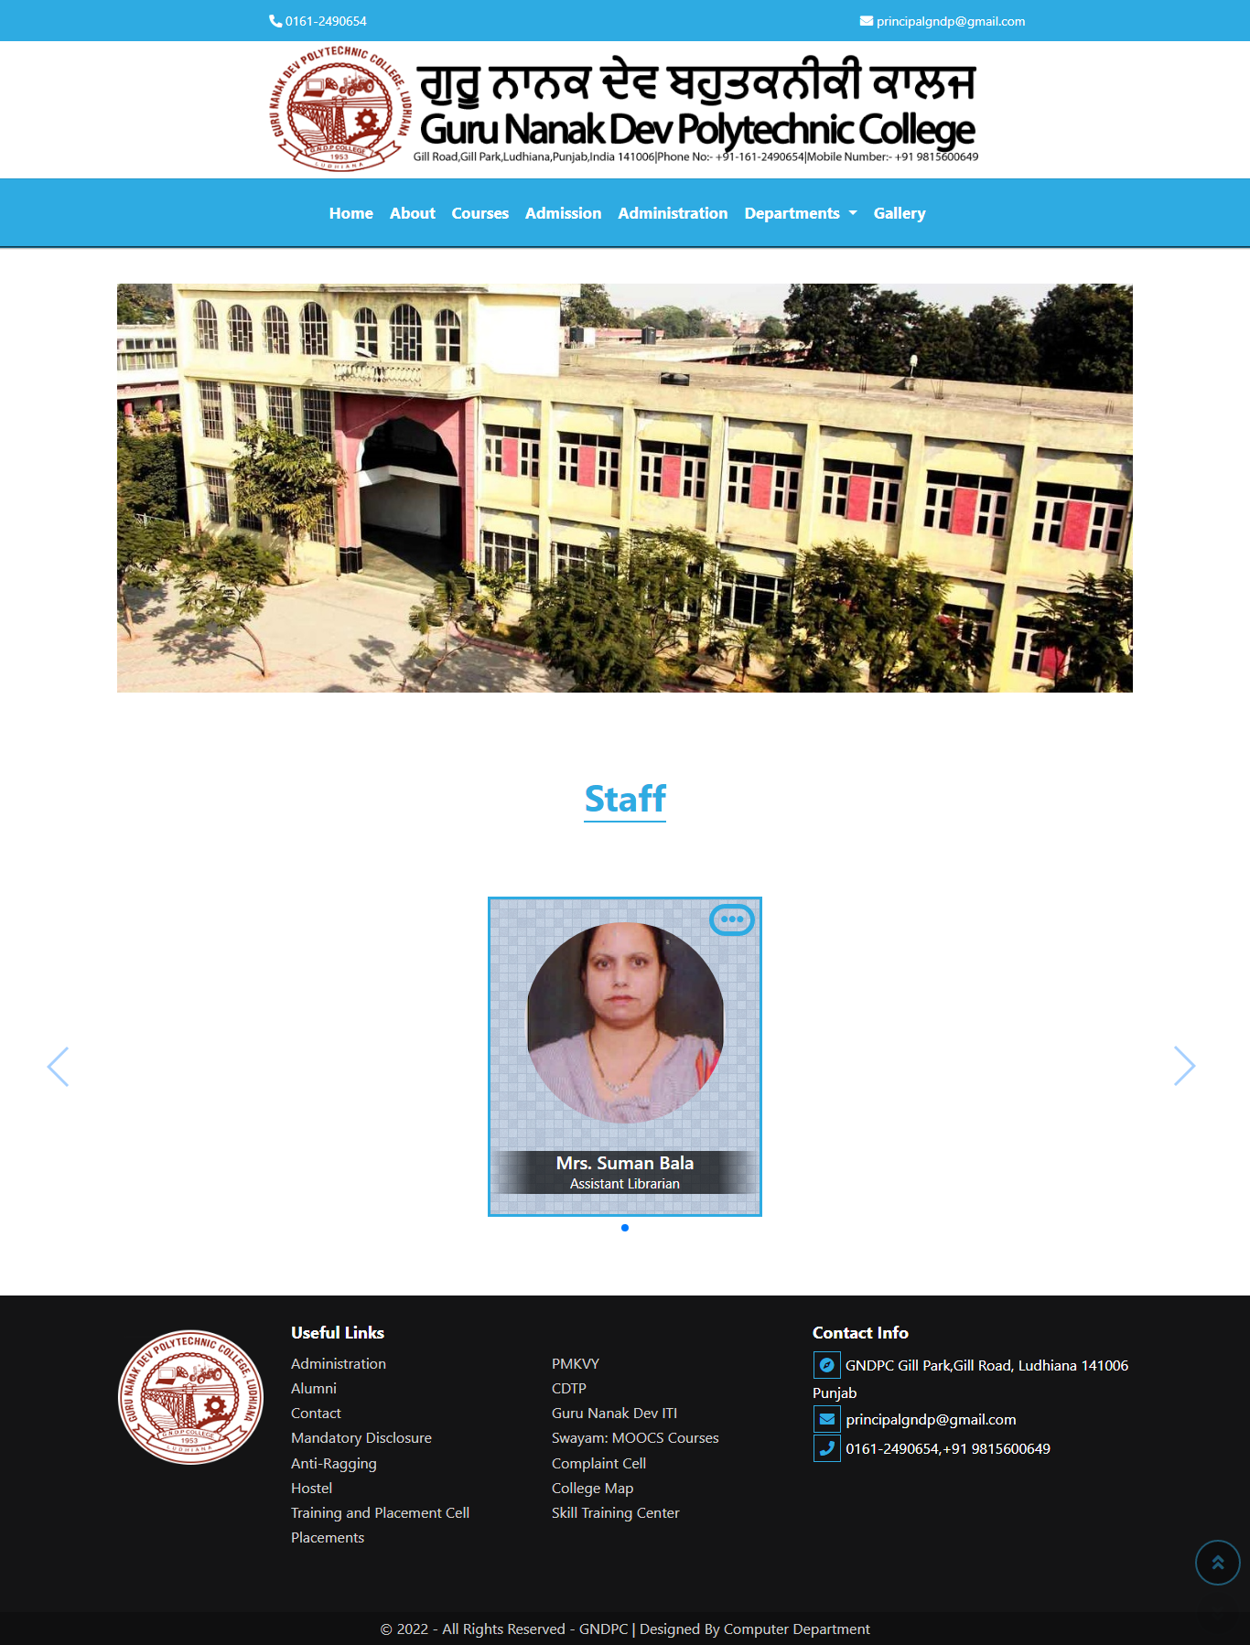

* 1. **Disadvantages of Current System**
* Current System does not provide any details about the library.
* Currently, there is no image of the library available on the website.
* There is no information about how many books, journals, newspapers, etc. are currently available in the library.
* It does not shows all the Staff members.
* The design of the page looks a bit old and out-dated.
* There is no admin portal for the staff members of the librarian, which might help them to store the data of the students related to books issued, etc. on the web portal.
* Many students lose their Library Membership Form and many times they are unable to get their hands on the new Library Membership Form easily, leading to long delay before they can issue the books from the Library.

**CH – 2**

**SCOPE AND OBJECTIVE**

* 1. **Project Scope**

Now-a-days, when everything is becoming digital, how is it possible that our Library still follows the traditional system of storing data on the registers. Library Management System is the only system by which we can help our College Library to grow and help the students in need and also automate the system of the issuing the books, calculating the fine, etc.

* 1. **Project Objective**
* Our project will help to reduce the data redundancy, by storing all the data at one place only.
* Provide the students with Library Membership Form directly on the website.
* Provide the students with the details of the books, journals, newspapers, etc. available in the Library.
* Provide any new user the glimpse of how our college Library looks like.
* Allow the students to create their own Web-Portal where they can keep track of their Library Membership Form, and other stuff like books issued, their due date and the total fine on overdue books.

**CH - 3**

**REQUIREMENT**

**3.1 Software**

**3.1.1. Text editor**

A text editor is a type of computer program that edits plain text Such programs are sometimes known as "notepad" software, following the naming of Microsoft Notepad Text editors are provided with operating systems and software development packages, and can be used to change files such as configuration files. Documentation files and programming language source code. We used *‘VS Code’* as text editor.

**3.1.2. Browser**

A web browser (commonly referred to as a browser) is a software application for accessing information on the World Wide Web. When a user requests a web page from a particular website, the web browser retrieves the necessary content from a web server and then displays the page on the user's device. We used ***‘Google Chrome’*** and **‘*Microsoft Edge*’** as a browser for our project.

**3.1.3. XAMPP Software**

To run the project on local machine we need to install XAMPP software in our PC. XAMPP is an abbreviation where X stands for Cross-Platform, A stands for Apache, M stands for MYSQL, and the Ps stand for PHP and Perl, respectively. It is an open-source package of web solutions that includes Apache distribution for many servers and command-line executables along with modules such as Apache server, MariaDB, PHP, and Perl.

XAMPP helps a local host or server to test its website and clients via computers and laptops before releasing it to the main server. It is a platform that furnishes a suitable environment to test and verify the working of projects based on Apache, Perl, MySQL database, and PHP through the system of the host itself. Among these technologies, Perl is a programming language used for web development, PHP is a backend scripting language, and MariaDB is the most vividly used database developed by MySQL. phpMyAdmin is a free software tool written in PHP, intended to handle the administration of MySQL over the Web. phpMyAdmin supports a wide range of operations on MySQL and MariaDB. Frequently used operations (managing databases, tables, columns, relations, indexes, users, permissions, etc.) can be performed via the user interface, while you still have the ability to directly execute any SQL statement.

* **Features**
* Intuitive web interface
* Support for most MySQL features
* browse and drop databases, tables, views, fields and indexes
* create, copy, drop, rename and alter databases, tables, fields and indexes
* maintenance server, databases and tables, with proposals on server configuration
* execute, edit and bookmark any SQL-statement, even batch-queries
* manage MySQL user accounts and privileges
* manage stored procedures and triggers
* Import data from CSV and SQL
* Export data to various formats, CSV SQL, XML, PDF, ISO/IEC 26300 OpenDocument Text and Spreadsheet, Word, LATEX and others
* Administering multiple servers
* Creating graphics of your database layout in various formats
* Creating complex queries using Query-by-example (QBE)

**3.2 Hardware**

* **Latest OS**: Make sure you're running the latest version either Windows 10 or Windows 11
* **Processor:** 2 Gigahertz (GHz) or faster processor
* **RAM:** 4GB (DDR4) or more
* **Hard Disk Space:** 512 GB or more for data & 256GB (SSD) for OS
* **Graphics card:** DirectX 9 or later with WDDM 1.0 driver
* **Display:** 1920 x 1080
* **Camera:** For Website Photography we used DSLR Camera of Nikon which is Nikon Z6 and focal length of lens used is 35mm
  1. **Tools & Methodology**

**3.3.1 Introduction**

**Web development** refers to the building, creating, and maintaining of websites. It includes aspects such as web design, web publishing, web programming, and database management. It is the creation of an application that works over the internet i.e. websites.

* **There are two ways to create a websites**:

1. Dynamic Websites
2. Static Websites `
   * 1. **Dynamic Websites:** Dynamic Website is a website containing data that can be mutable or changeable. It uses client-side or server scripting to generate mutable content. Like a static website, it also contains HTML data.

There are two kinds of dynamic web pages i.e. client side scripting and server side scripting. The client-side web pages changes according to your activity on the web page. On the server-side, web pages are changed whenever a web page is loaded.

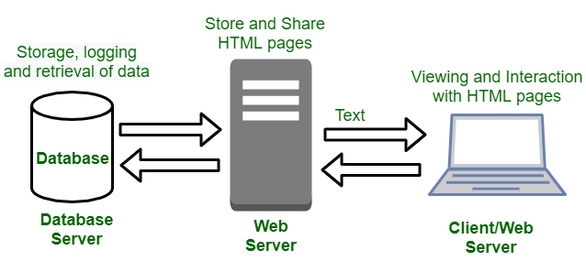**Example:** login & signup pages, application & submission forms, inquiry and shopping cart pages.

There are different languages used to create dynamic web pages like PHP, ASP, .NET and JSP. Whenever a dynamic page loads in browser, it requests the database to give information depending upon user’s input. On receiving information from the database, the resulting web page is applied to the user after applying the styling codes.

* + 1. **Static Websites: Static websites** are the websites that doesn’t change the content or layout dynamically with every request to the web server. Static websites display exactly the same information whenever anyone visits it. User sees the updated content of Static Website only when a web author manually updates them with a **text editor** or any web editing tool used for creating websites. Static webpages do not have to be simple plain text. They can feature multiple design and even videos.

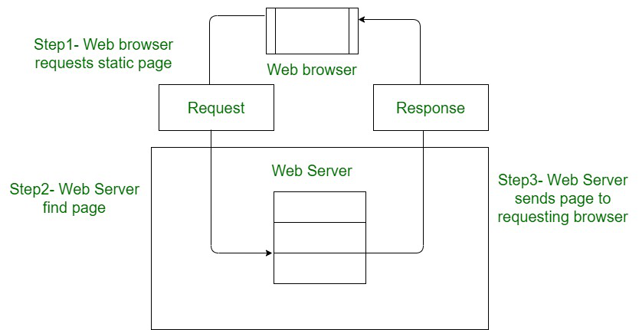

* + 1. **Types of Web Development**

Web Development can be classified into two types:

1. Frontend Web Development
2. Backend Web Development
   * 1. **Frontend Development:**The part of a website that the user interacts directly is termed as front end. It is also referred to as the ‘client side’ of the application.

* **Roadmap of Frontend Web Development:**
* **Structure Language:** HTML
* **Styling Language:** CSS
* **CSS Framework:** Bootstrap, Tailwind CSS, Bulma.
* **Programming Language :** JavaScript
* **JS Framework: ReactJS, AngularJS, VueJS.**

**3.3.6** [**Backend Development**](https://www.geeksforgeeks.org/which-one-is-most-demanding-back-end-web-framework-between-laravel-nodejs-and-django/)**:** Backend is the server side of a website. It is the part of the website that users cannot see and interact. It is the portion of software that does not come in direct contact with the users. It is used to store and arrange data.

* **Roadmap of Backend Web Development :**
* [**PHP**](https://www.geeksforgeeks.org/php-tutorials/)**:** PHP is a server-side scripting language designed specifically for web development.
* [**Java**](https://www.geeksforgeeks.org/java-tutorial/)**:**Java is one of the most popular and widely used programming language. It is highly scalable.
* [**Python**](https://www.geeksforgeeks.org/python-programming-language/)**:** Python is a programming language that lets you work quickly and integrate systems more efficiently.
* [**Node.js**](https://www.geeksforgeeks.org/nodejs-tutorials/)**:** Node.js is an open source and cross-platform runtime environment for executing JavaScript code outside a browser.
* **Back End Frameworks:** The list of backend frameworks are:

[Express](https://www.geeksforgeeks.org/introduction-to-express/), [Django](https://www.geeksforgeeks.org/django-tutorial/), [Rails](https://www.geeksforgeeks.org/how-to-install-ruby-on-rails-on-windows-and-linux/), [Laravel](https://www.geeksforgeeks.org/tag/laravel/), [Spring](https://www.geeksforgeeks.org/introduction-to-spring-framework/), etc.

* **SQL Database:** MariaDB, MySQL.
* **NoSQL Database:** Mongo DB.

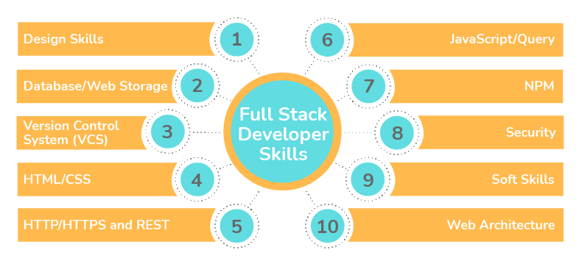

**3.3.7 HTML**

**3.3.7.1 What is HTML?**

HTML stands for Hyper Text Markup Language. It is used to design web pages using the markup language. HTML is the combination of Hypertext and Markup language. Hypertext defines the link between the web pages and markup language defines the text document within the tag that define the structure of web pages.

**3.3.7.2What is HTML used for?**

HTML is used to create the structure of web pages that are displayed on the World Wide Web (www). It contains Tags and Attributes that are used to design the web pages. Also, we can link multiple pages using Hyperlinks.

**3.3.7.3 HTML Basic Format Page Structure**

The basic structure of an HTML page is laid out below. It contains the essential building-block elements (i.e. doctype declaration, HTML, head, title, and body elements) upon which all web pages are created.

* [**<!DOCTYPE HTML>**](https://www.geeksforgeeks.org/html-doctypes/)**–** A DOCTYPE or document type declaration is an instruction that tells the web browser about the markup language in which the current page is written. It is not an element or tag. The DOCTYPE declaration is not case-sensitive.
* [**<HTML>**](https://www.geeksforgeeks.org/html-html-tag/)**–** This tag is used to define the root element of HTML document. This tag tells the browser that it is an HTML document. It is the second outer container element that contains all other elements within it.
* [**<HEAD>**](https://www.geeksforgeeks.org/html-head-tag/)**–** This tag is used to define the head portion of the HTML document that contains information related to the document. Elements within the head tag are not visible on the front-end of a webpage.
* [**<TITLE>**](https://www.geeksforgeeks.org/html-head-tag/)**–** It is used to create a title of the document and the title appears in the title bar at the top. At least one title appears in every document. The title portion of the document starts with <title> and ends with </title>, and in between, enter the text that you want as the title.
* [**<BODY>**](https://www.geeksforgeeks.org/html-body-tag/)**–** The body tag is used to enclose all the visible content of a webpage. In other words, the body content is what the browser will show on the front end.

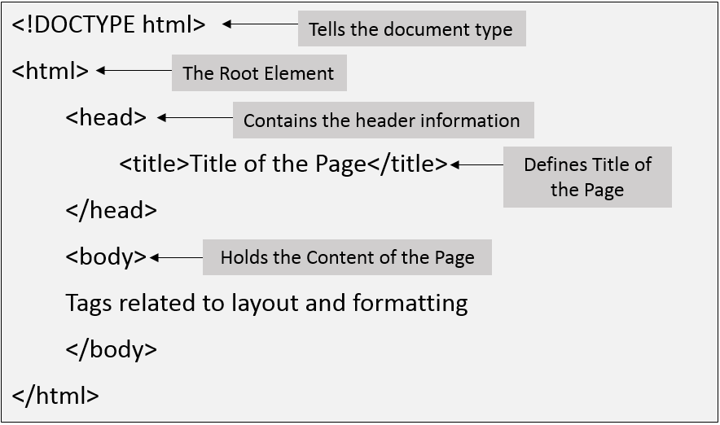

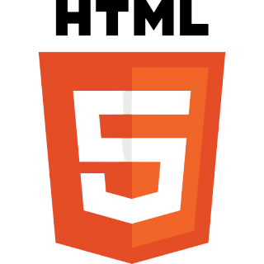

**3.3.7.4 History of HTML**

HTML was originally developed by Tim burners-Lee while at CERN, and popularized by browser developed at NCSA. During the course of 1990s it has blossomed with the explosive growth of the web. During this time, HTML has been extended in a number of ways. The web depends on web page authors and vendors sharing the same conventions for HTML. This has motivated joint work on specifications for HTML. The first version of HTML was just called HTML. The basic tags have not changed much. HTML has tried to stay backward –compatible so that new versions of HTML do not contradict old versions.

**3.3.7.5 Versions of HTML**

Let’s see the significance of the individual Versions of Html in details-

**1. HTML 1.0**

* The basic version of HTML has support for basic elements like text controls and images. This was the very basic version of HTML with less support for a wide range of HTML elements. It does not have rich features like styling and other things that were related to how content will be rendered in a browser.
* The initial version of HTML does not provide support for tables, font support, etc., as it provides us in the latest version.
* We would also like to discuss that W3C did not exist before HTML 2.0; hence it does not show details about HTML 1.

**2. HTML 2**

* HTML version 2.0 was developed in 1995 with basic intention of improving HTML version 1.0
* Now a standard got started to develop so as to maintain common rules and regulations across different browsers. HTML 2.0 has improved a lot in terms of the markup tags. In HTML 2.0 version concept of form came into force. Forms were developed, but still, they had basic tags like text boxes, buttons, etc.
* Also, the table came as an [HTML tag](https://www.educba.com/basic-html-tags/). Now, in HTML tag 2.0, browsers also came with the concept of creating their own layers of tags that were specific to the browser itself. W3C was also formed. The main intention of W3C is to maintain standard across different web browsers so that these browsers understand and render HTML tags in a similar manner.

1. **HTML 3.2**

* It was developed in 1997. After HTML 2.0 was developed, the next version of HTML was 3.2
* With version 3.2 of HTML, HTML tags were further improved. It is worth noting that because of W3C standard maintenance, the newer version of HTML was 3.2 instead of 3.
* Now, HTML 3.2 has better support for new form elements. Another important feature what HTML 3.2 implemented was support for CSS. CSS stands for [Cascading Style Sheet](https://www.educba.com/what-is-css/). It is CSS that provides features to make HTML tags look better on rendering it on browsers. CSS helps to style HTML elements.
* With the upgradation of browsers to HTML 3.2, the browser also supported for [frame tags](https://www.educba.com/frame-tag-in-html/), although HTML specifications still do not support frame markup tags.

**4. HTML 4.01**

* It was developed in 1999. It extended the support of cascading styling sheets. In version 3.2, CSS were embedded in HTML page itself. Therefore, if the website has various web pages to apply to the style of each page, we must place CSS on each web page. Hence there was a repetition of the same block of CSS.
* To overcome this thing, in version 4.01 concept of an external styling sheet emerged. Under this concept, an external CSS file could be developed, and this external styling file could be included in HTML itself. HTML 4.01 provided support for further new tags of HTML.

**5. HTML5**

|  |  |
| --- | --- |
| <b> | This is a physical tag, which is used to bold the text written between it. |
| <strong> | This is a logical tag, which tells the browser that the text is important. |
| <i> | This is a physical tag which is used to make text italic. |
| <em> | This is a logical tag which is used to display content in italic. |
| <mark> | This tag is used to highlight text. |
| <u> | This tag is used to underline text written between it. |
| <tt> | This tag is used to appear a text in teletype. (not supported in HTML5) |
| <strike> | This tag is used to draw a strikethrough on a section of text. (Not supported in HTML5) |
| <sup> | It displays the content slightly above the normal line. |
| <sub> | It displays the content slightly below the normal line. |
| <del> | This tag is used to display the deleted content. |
| <ins> | This tag displays the content which is added |
| <big> | This tag is used to increase the font size by one conventional unit. |
| <small> | This tag is used to decrease the font size by one unit from base font size. |

* This is the latest version of HTML. For a developer, it could be used in 2014. It came up with lots of HTML tags support. [HTML5](https://www.educba.com/html5-elements/) provided support for new form elements like input element s of different types; geolocations[support tags](https://www.educba.com/html-geolocation/), etc.
* Let us look at a few of the tags which were added to HTML5
* **Email –** New HTML5 tag, which was added, is the input element of type email. This is a form tag, although it could be used outside of a form tag also. This tag checks the validation of the input value. It checks whether the value inserted is a valid email.
* **Password –** This is another form tag that was added to receive a password from the user. Being the password type field, the user types in the field are not visible directly to the user but are represented by special symbols. These symbols save the password from getting revealed on the browser.
* **Audio tag –** This is a new audio tag that was implemented in [HTML5](https://www.educba.com/what-is-html5/). This tag helps to add audio to our web page. We can use this tag to embed an audio clip into a web page. This audio tag could be played on a webpage.
* **Semantic tags –** Semantic tags are also known as structural tags. Structural tags are the tags that provide structure to the HTML page. It helps it divide the HTML page into different structures. These structures get combined into an HTML page itself to form an HTML web page. Few of the important HTML semantic tags are figcaption, <header>, <footer>
* **Section tag –** This tag is used to semantic a section in an HTML page. A [section tag](https://www.educba.com/html-section-tag/) represents a section on a web page.

**3.3.7.6 HTML Formatting Tags**

HTML Formatting is a process of formatting text for better look and feel. HTML provides us ability to format text without using CSS. There are many formatting tags in HTML.

**3.3.7.7 HTML Image**

HTML img tag is used to display image on the web page. HTML img tag is an empty tag that contains attributes only, closing tags are not used in HTML image element.

* **Attributes of HTML img tag:**
* **src:** It is a necessary attribute that describes the source or path of the image. It instructs the browser where to look for the image on the server.
* The location of image may be on the same directory or another server.
* **alt:** The alt attribute defines an alternate text for the image, if it can't be displayed. The value of the alt attribute describe the image in words. The alt attribute is considered good for SEO prospective.
* **width:** It is an optional attribute which is used to specify the width to display the image. It is not recommended now. You should apply CSS in place of width attribute.
* **height:** It h3 the height of the image. The HTML height attribute also supports iframe, image and object elements. It is not recommended now. You should apply CSS in place of height attribute.

**Example:** <img src="animal.jpg" height="180" width="300" alt="animal image">

**3.3.7.8 HTML Table**

HTML table tag is used to display data in tabular form (row * column). There can be many columns in a row. HTML tables are used to manage the layout of the page e.g. header section, navigation bar, body content, footer section etc. But it is recommended to use div tag over table to manage the layout of the page

|  |  |
| --- | --- |
| **Tag** | **Description** |
| <table> | It defines a table. |
| <tr> | It defines a row in a table. |
| <th> | It defines a header cell in a table. |
| <td> | It defines a cell in a table. |
| <caption> | It defines the table caption. |
| <colgroup> | It specifies a group of one or more columns in a table for formatting. |
| <col> | It is used with <colgroup> element to specify column properties for each column. |
| <tbody> | It is used to group the body content in a table. |
| <thead> | It is used to group the header content in a table. |
| <tfooter> | It is used to group the footer content in a table. |

**3.3.7.9 HTML Links**

Hyperlinks allow visitors to navigate between Web sites by clicking on words, phrases, and images. Thus you can create hyperlinks using text or images available on a webpage. A link is specified using HTML tag <a>. This tag is called **anchor tag** and anything between the opening <a> tag and the closing </a> tag.

**Example:** <a href = "/html/index.htm" target = "_blank">HOME</a>

**3.3.7.10 HTML Lists**

HTML Lists are used to specify lists of information. All lists may contain one or more list elements. There are three different types of HTML lists:

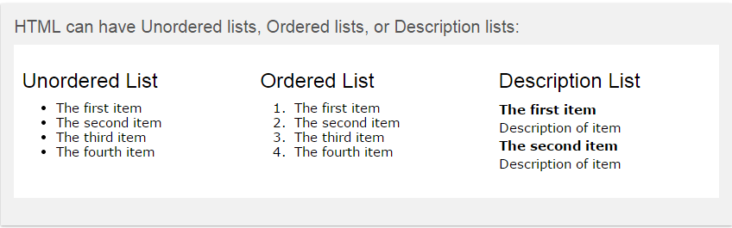

**4.5.10 HTML Forms**

<form> is a HTML element to collect input data with containing interactive controls. Form is a container that contains input elements like text, email, number, radio buttons, checkboxes, submit buttons, etc. Forms are generally used when you want to collect data from the user.

**Syntax:** <form>

<!--form elements-->

</form>

**3.3.7.11 Form elements:**

These are the following HTML <form> elements:

* **<LABEL>:** It defines label for <form> elements.
* **<INPUT>:** It is used to get input data from the form in various types such as text, password, email, etc. by changing its type.
* **<BUTTON>:** It defines a clickable button to control other elements or execute a functionality.
* **<SELECT>:** It is used to create a drop-down list.
* **<TEXTAREA>:** It is used to get input long text content.
* **<FIELDSET>:** It is used to draw a box around other form elements and group the related data.
* **<legend>:** It defines caption for fieldset elements.
* **<datalist>:** It is used to specify pre-defined list options for input controls.
* **<output>:**It displays the output of performed calculations.
* **<option>:** It is used to define options in a drop-down list.
* **<optgroup>:** It is used to define group-related options in a drop-down list.

**3.3.7.12 Advantages of HTML:**

* Basically HTML5 has its many new syntactical features, which include the <video>, <audio>elements, as well as the integration of SVG content. Due to these new elements, it will be very easy to integrate multimedia and graphical content to web without using flash and third party plug-in. There are also another new elements like <section>, <article>, <header> and <nav> which enrich the semantic value of the document. Other major advantages of HTML5 are described below.
* **Mutuality:** Due to usability purpose the web sites made by developers are highly interactive nowadays and for this developers need to include fluid animations, stream video, play music and Social Network sites like Facebook and Twitter into the websites. Till now they have only the option to integrate it with the help of Flash or Silver light, Flex or java script like tools. But these consume so much time to develop and even the complexity of web application also increased. But now with the help of HTML5 it is possible to embed video and audio, high quality drawings, charts and animation and many other rich content without using any plug-in and third party program as the functionality is built into the browser.
* **Cleaner markup / Improved Code:** HTML 5 will enable web designers to use cleaner, neater code; we can remove most div tags and replace them with semantic HTML 5 elements. Improved Semantics: Now it is easy to see which parts of the page are headers, nav, footers, aside, etc as the tags are specific for these all and most importantly know what their meaning and purpose is in whole the format. By using HTML5 elements we can increase the semantic value of the web page as the codes are very standardized.
* **Elegant forms:** HTML5 enables designer to use fancier forms. Even it makes form validation native to HTML, User interface enhancements and reduced need for JavaScript (only needed in browsers that don’t support form types). There will be different type of text inputs, search and different fields for different purpose.
* **Consistency:** As websites adopt the new HTML5 elements we will see greater consistency in terms of the HTML used to code a web page on one site compared to another. This will make it easier for designers and developers to immediately understand how a web page is structured.
* **Improved Accessibility:** Different technologies can elaborate on the features with the help of HTML5, as they can immediately make more detailed understanding of the structure of a page by take a look at HTML5 elements it has.
* **Fulfil the need of Web application:** Many new features and standards have emerged as part of HTML 5. Once you detect the available features in today’s browsers, you can take advantage of those features in your application. Main focus of HTML5 is to make easier application with easy front-ends, drag and drop tools, discussion boards, wikis and other useful elements.
* **Offline Application cache:** All browsers have some kind of caching m after a sometime, you open up your laptop and click the Back button in the browser hoping to see the previous page that was opened. However, as you are not connected to the internet and the browser didn’t cache the page properly, you are unable to view that page. You then click the Forward button thinking that at least that page will load, but it doesn’t. You need to reconnect to the internet to be able to view the pages. HTML 5, thankfully, provides a smarter solution. While building the site, the developer can specify the files that the browser should cache. So, even if you refresh the page when you are offline, the page will still load correctly. This sort of caching has several advantages like offline browsing, files load much faster and reduced load on server.
* **Client-side database:** While cookies have been used to track unique user data for years, they have serious disadvantages. The largest flaw is that all of your cookie data is added to every HTTP request header. This can end up having a measurable impact on response time. So a best practice is to reduce cookie size. With HTML5 we can better by using session storage and local storage (two different storage in HTML5) in place of cookies. It is not a permanent database, but enables you to store structured data, temporarily.

**3.3.7.13 Disadvantages of HTML:**

* HTML has a few significant drawbacks, such as its static nature, its inability to render content in an aesthetically pleasing way, its well-known compatibility issues and its overall complexity.
* **Insufficient for Dynamic Pages:** Back in the early days of the World Wide Web, no one expected a Web page to do anything besides displaying static words and images, much like a book does. Nowadays, Internet users expect more out of their favourite websites, from infinite scrolling pages such as the Twitter timeline to search boxes that automatically generate suggestions based on input.
* **Limited for Displaying Content:** HTML is a structuring language that allows you to attach a virtual label to sections of your content. To circumvent that limitation, a separate language had to be invented to handle the presentation of Web pages Cascading Style Sheets. In effect, this limitation forces Web designers and developers to maintain two separate sets of files: HTML files that contain the content of the website and structures it, and CSS files that describe how a page should look.
* **Unpredictable Behaviours across Browsers:** If you attempt to view the same website using three different browsers, you may be surprised to find that pages are sometimes displayed differently depending on whether you use Internet Explorer, Google Chrome or Firefox.
* **Difficult to Learn:** Anyone who wishes to create a website using HTML code may spend weeks first just learning HTML. With each major release, HTML becomes more complex and new tags are added while others are deprecated, forcing Web developers to spend valuable time learning how to implement the newly added features.
  + 1. **CSS**

**3.3.8.1 What is CSS?**

**C**ascading **S**tyle **S**heets, fondly referred to as CSS, is a simple design language intended to simplify the process of making web pages presentable.

****CSS handles the look and feel part of a web page. Using CSS, you can control the color of the text, the style of fonts, the spacing between paragraphs, how columns are sized and laid out, what background images or colors are used, layout designs, variations in display for different devices and screen sizes as well as a variety of other effects.

**3.3.8.2 Versions:**

* **CSS 1.0:** The CSS Level 1 W3C Recommendation was made in December 1996. The release of CSS 1 supported: font properties, text attributes, alignment of text, tables, images and more, colors of text and backgrounds, spacing of words, letters and lines, margins, borders, padding and positioning, and unique identification and classification of groups of attributes.
* **CSS 2.0:** In May of 1998, the W3C released CSS 2 which added new capabilities including z-index, media types, bidirectional text, absolute, relative and fixed positioning, and support for aural style sheets. Not long after the release of CSS 2, a new browser, Opera was released which also supported CSS.
* **CSS 3.0:** With the release of CSS 3, capabilities were broken into modules. Between June 2011 and June 2012, the following four modules were released as formal recommendations: color, selectors' level 3, and namespaces and media queries.

**3.3.8.3 Types of Stylesheet:**

* External Stylesheet
* Internal Stylesheet
* Inline Stylesheet
  + - * **External Stylesheet:** With an external style sheet, you can change the look of an entire website by changing just one file! Each page must include a reference to the external style sheet file inside the element. The element goes inside the section:

**Syntax:**

<Head>

<link rel=”stylesheet” href=”style.css>

</head>

* + - * **Internal Stylesheet:** An internal style sheet may be used if one single page has a unique style. Internal styles are defined within the section of an HTML page:

**Syntax:**

<head>

<Style>

<Body> {

Background-color: red;

}

h1 {

Color: maroon;

Margin-left: 40px;

}

</style>

</head>

* + - * **Inline Stylesheet:** An inline style may be used to apply a unique style for a single element. To use inline styles, add the style attribute to the relevant element. The style attribute can contain any CSS property. The example below shows how to change the color and the left margin of a element.

**Syntax:**

<h1 style="color:blue; margin-left: 30px ;">This is a heading</h1>

**3.3.8.4 Advantages of CSS:**

* **CSS saves time:** When most of us first learn HTML, we get taught to set the font face, size, color, style etc. every time it occurs on a page. This means we find ourselves typing (or copying & pasting) the same thing over and over again. With CSS, you only have to specify these details once for any element. CSS will automatically apply the specified styles whenever that element occurs.
* **Pages load faster:** Less code means faster download times.
* **Easy maintenance:** To change the style of an element, you only have to make an edit in one place.
* **Superior styles to HTML:** CSS has a much wider array of attributes than HTML

**3.3.8.5 Disadvantages of CSS:**

* **Browser compatibility:** Browsers have varying levels of compliance with Style Sheets. This means that some Style Sheet features are supported and some aren't. To confuse things more, some browser manufacturers decide to come up with their own proprietary tags.
* CSS works differently on different browsers. IE and Opera supports CSS as different logic.

**3.3.8.6 CSS Selector**

CSS selectors are used to select the content you want to style. Selectors are the part of CSS rule set. CSS selectors select HTML elements according to its id, class, type, attribute etc.

There are several different types of selectors in CSS.

* **CSS Element Selector:** The element selector selects the HTML element by name.
* **CSS Id Selector:** The id selector selects the id attribute of an HTML element to select a specific element. It is written with the hash character (#), followed by the id of the element.
* **CSS Class Selector:** The class selector selects HTML elements with a specific class attribute. It is used with a period character. (Full stop symbol) followed by the class name.
* **CSS Universal Selector:** The universal selector is used as a wildcard character. It selects all the elements on the pages.
* **CSS Group Selector:** The grouping selector is used to select all the elements with the same style definitions.

**3.3.8.7 Properties of CSS**

1. **Color Property**

The color property in CSS is used to set the color to text, the background of the webpage, and also to set the color of borders.

**Ex:**  color: red;

1. **Background Property**

CSS background property is used to define the background effects on element. There are 5 CSS background properties that affects the HTML elements:

* **background-color:** This property is used for change the background of the page.
* **background-image:** This property is used to insert the image in webpage.
* **background-repeat:** This property is used to repeat the background in x-axis and y-axis both.
* **background-attachment:** This is used to attach the background fixed with the webpage .Others are scrolled.
* **background-position:** It is used to set the position of the div content in top, bottom, left, right.

1. **Font Property**

CSS Font property is used to control the look of texts. By the use of CSS font property you can change the text size, color, style and more. You have already studied how to make text bold or underlined. Here, you will also know how to resize your font using percentage.

These are some important font attributes:

* **CSS Font color:** This property is used to change the color of the text. (standalone attribute)
* **CSS Font family:** This property is used to change the face of the font.
* **CSS Font size:** This property is used to increase or decrease the size of the font.
* **CSS Font style:** This property is used to make the font bold, italic or oblique.
* **CSS Font variant:** This property creates a small-caps effect.
* **CSS Font weight:** This property is used to increase or decrease the boldness and lightness of the font.

1. **Text Formatting Property**

CSS text formatting properties is used to format text and style text. CSS text formatting include following properties:

* **Text-color:** It is used to change the text color.
* **Text-alignment:** There are Four text alignment are Left, Center, Right, Justify.
* **Text-decoration:** This property is used to remove any text formatting easily by using none value or to use a underline of the text, etc.
* **Text-transformation:** This property change the case of text. It consists of Lowercase, Uppercase, capitalize, none, etc.
* **Text-indentation:** Text indentation property is used to indent the first line of the paragraph. The size can be in px, cm, pt.
* **Letter spacing:** This property is used to specify the space between the characters of the text. The size can be given in px.
* **Line height:** This property is used to set the space between the lines.
* **Text-direction:** Text direction property is used to set the direction of the text.
* **Text-shadow:** Text shadow property is used to add shadow to the text. You can specify the horizontal size, vertical size and shadow color for the text.
* **Word spacing:** Word spacing is used to specify the space between the words of the line. The size can be given in px.

1. **Text Formatting Property**

Shorthand properties allow us to write multiple properties in a single line and in a compact way. They are useful as they provide clean code and also decrease the LOC (Line of Code). The Shorthand properties we will be covering:

* **Background**
* **Example:** background:#000 url(images/bg.png) no-repeat left top;
* **Font**
* **Example:** font: italic bold 18px/150% Arial, sans-serif;
* **Border**
* **Example:** border: 1px solid #000;
* **Outline**
* **Example:** outline: 1px solid #000;
* **Margin**
* **Example:** margin: 10px 5px 10px 5px;
* **Padding**
* **Example:** padding: 10px 5px 10px 5px;
* **List**
* **Example:** list-style: disc inside url(disc.png);

1. **Layout properties**
   1. **Display property:** In this property the elements are displayed in two forms-

* Inline Display
* Block Display

**b. Float property:** Basically float is defines that how our element should be float on any direction. The float property is used for positioning and formatting the contents

The Float property can have on these following values:

* **Left:** The elements Floats to the left of its container.
* **Right:** The element floats to the sight of the consumer.
* **None:** The element does not float. This is default.
* **Inherit:** The Element inherits the float value of the parents.
* **Clear Property:** Clear property is used to clear the all property of float it can be cleared all floating point. There by cleaning it, the element or a document or a webpage working in formal form.

1. **Position Property:** The position property specifies the type of positioning method and for an element. There are five different position values:

* **Position: Static; - HTML** elements are positioned static by default.static. Positioned elements are not affected by the top, bottom, left. and right property
* **Position: Relative**; - In which the element is positioned relative to is normal position. In this property relative value a relatively positioned element will cause it to be adjusted away from its normal position.
* The top/right/bottom left index was now work. Other content will not go be adjusted to fit into any gap left by element.
* **Position: Fixed; -** An element is positioned relative to the viewport or browser windows, which means it always stays on fixed same place even if pages scrolled.
* **Position: Absolute; -** The element is removed from the flow relativity positioned its first non static ancestor. Absolute positioned element are removed from the normal flow, and can overlap elements. Position: Sticky; - An element is position based on the user scroll position. When the user scroll the window to up to down or down to up the position:sticky element its fixed on their specific position but the other content will move or scroll.

1. **CSS Flexbox**

The flexbox or flexible box model in CSS is a one-dimensional layout model that has flexible and efficient layouts with distributed spaces among items to control their alignment structure ie., it is a layout model that provides an easy and clean way to arrange items within a container. Flexbox can be useful for creating small-scales layouts & is responsive and mobile-friendly.

* **Features of flexbox:**
* A lot of flexibility is given.
* Arrangement & alignment of items.
* Proper spacing
* Order & Sequencing of items.
* Bootstrap 4 is built on top of the flex layout.
  + - * **Before the flexbox model, we had 4 layout modes:**
* **Block:** It is used to make sections in web pages.
* **Inline:** It is used for text.
* **Table:** It is used for two-dimensional table data.
* **Positioned:**It is used for the explicit position of an element.
  + - **There are 2 main components of the Flexbox:**
* **Flex Container:** The parent “div” which contains various divisions is called a flex container.
* **Flex Items:** The items inside the container “div” are flex items.

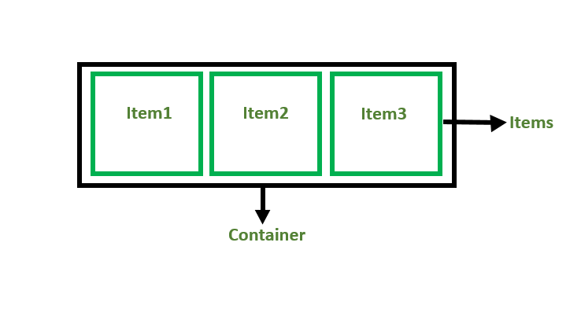

* + - * **Flexbox Axis:** While working with Flexbox, we deal with 2 axes:

1. 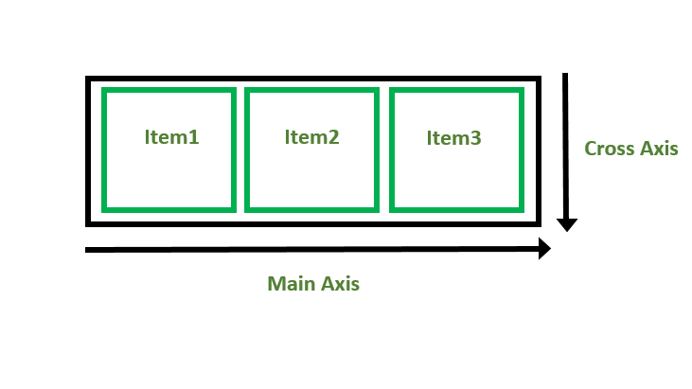Main Axis
2. Cross Axis
   * + - **Concept of Flex Direction:**

* **left to right:** flex-direction: row;
* **right to left:** flex-direction: row-reverse;
* **top to bottom:** flex-direction: column;
* **bottom to top:** flex-direction: column-reverse
  + - **CSS grid layout module**

The CSS grid layout module is used to create a grid-based layout system, with the help of rows and columns it makes it easier to design any webpage without using floats and positioning.

**Syntax:**

.class

{

display: grid;

}

* + - * **CSS Grid Layout Properties:**These are the following grid-layout properties:
* [**column-gap**](https://www.geeksforgeeks.org/css-column-gap-property/)**:** It is used to specify the amount of gap between the columns in which a given text is divided using the column-count property.
* [**gap**](https://www.geeksforgeeks.org/css-gap-property/)**:**It is used to set the spacing also caller gutter between the rows and columns.
* [**grid**](https://www.geeksforgeeks.org/css-grid-property/)**:** It offers a grid-based layout system, with rows and columns, making it easier to design web pages without floats and positioning.
* [**grid-area**](https://www.geeksforgeeks.org/css-grid-area-property/)**:** It is used to set a grid item size and location in a grid layout.
* [**grid-auto-columns**](https://www.geeksforgeeks.org/css-grid-auto-columns-property/)**:** It is used to specify the size for the columns of implicitly generated grid containers.
* [**grid-auto-flow**](https://www.geeksforgeeks.org/css-grid-auto-flow-property/)**:** It specifies exactly how auto-placed items get flow into the grid.
* [**grid-auto-rows**](https://www.geeksforgeeks.org/css-grid-auto-rows-property/)**:** It is used to specify the size for the rows of implicitly generated grid containers.
* [**grid-column**](https://www.geeksforgeeks.org/css-grid-column-property/)**:** It describes the number of properties that allow to design of grid structures and control the placement of grid items using CSS.
* [**grid-column-end**](https://www.geeksforgeeks.org/css-grid-column-end-property/)**:** It explains the number of columns an item will span, or on which column-line the item will end.
* [**grid-column-gap**](https://www.geeksforgeeks.org/css-grid-column-gap-property/)**:** It is used to set the size of the gap between the columns in a grid layout.
* [**grid-column-start**](https://www.geeksforgeeks.org/css-grid-column-start-property/)**:** It defines for which column line item will start.
* [**grid-gap**](https://www.geeksforgeeks.org/css-grid-gap-property/)**:** It is used to sets the size of the gap between the rows and columns in a grid layout.
* [**grid-row**](https://www.geeksforgeeks.org/css-grid-row-property/)**:** It is used to specify the size and location in a grid layout.
* [**grid-row-gap**](https://www.geeksforgeeks.org/css-grid-row-gap-property/)**:** It is used to define the size of the gap between the grid elements.
* [**grid-row-start**](https://www.geeksforgeeks.org/css-grid-row-start-property/)**:** It is used to define the grid items’ start position within the grid row by specifying the inline start edge of its grid area.
* [**grid-template**](https://www.geeksforgeeks.org/css-grid-template-property/)**:** It is a [shorthand property](https://www.geeksforgeeks.org/css-shorthand-properties/) for defining grid columns, rows, and areas.
* [**grid-template-areas**](https://www.geeksforgeeks.org/css-grid-template-areas-property/https:/www.geeksforgeeks.org/css-grid-template-areas-property/)**:** It is used to specify the area within the grid layout.
* [**grid-template-columns**](https://www.geeksforgeeks.org/css-grid-template-columns-property/)**:** It is used to set the number of columns and size of the columns of the grid.
* [**grid-template-rows**](https://www.geeksforgeeks.org/css-grid-template-rows-property/)**:** It is used to set the number of rows and height of the rows in a grid.

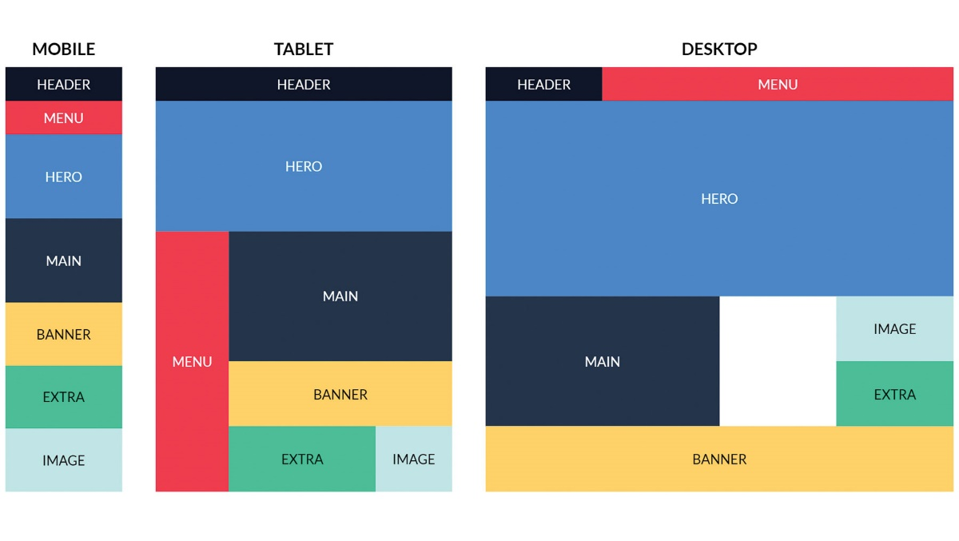

* + - **CSS Transition**

Transitions in CSS allows us to control the way in which transition takes place between the two states of the element. For example, when on hovering your mouse over a button, you can change the background color of the element with help of CSS selector and [pseudo-class](https://www.geeksforgeeks.org/css-pseudo-classes/).

* **transition-property:**This property allows you to select the CSS properties which you want to animate during transition(change).

**Syntax:** transition-property: none | all | property | property1, property2, ..., propertyN;

* **transition-duration:** This property allows you to determine long it will take to complete the transition from one CSS property to the other.
* **Syntax:** transition-duration: time;
* Here, time can be in seconds(s) or milliseconds(ms), you should use ‘s’ or ‘ms’ after the number (without quotes).
* **transition-timing-function:** This property allows you to determine the speed of change and the manner of change, during the transition. Like, the change should be fast at the beginning and slow at the end, etc.
* **Syntax:** transition-timing-function: ease | ease-in | ease-out | ease-in-out | linear |step-start | step-end;
* **transition-delay:** This property allows you to determine the amount of time to wait before the transition actually starts to take place.
* **Syntax:** transition-delay: time;
* **transition-delay:** This property allows you to determine the amount of time to wait before the transition actually starts to take place.
* **Syntax:** transition-delay: time;
  + - **CSS Animation**

CSS Animations is a technique to change the appearance and behaviour of various elements in web pages. It is used to control the elements by changing their motions or display.

**The @keyframe_rule:** Keyframes are the foundations with the help of which CSS Animations works. They define the display of the animation at the respective stages of its whole duration.

**Example:**  @keyframes color {

         0% {

             background-color: red; }

         50% {

             background-color: orange;  }

         100% {

             background-color: brown;  }

        }

* + - * **Animation Properties:** There are certain animation properties given below:
* [**animation-name**](https://www.geeksforgeeks.org/css-animation-name-property/)**:** It is used to specify the name of the *@keyframes* describing the animation.

**Syntax:** animation-name: animation_name;

* [**animation-duration**](https://www.geeksforgeeks.org/css-animation-duration-property/)**:** It is used to specify the time duration it takes animation to complete one cycle.

**Example:**   animation-duration: 5s;

* [**animation-timing-function**](https://www.geeksforgeeks.org/css-animation-timing-function-property/)**:** Specifies how the animation makes transitions through keyframes. It can have the following values:
* **ease:** The animation starts slowly, then fast, and then finally ends slowly (this is the default)
* **linear:** The animation plays with the same speed from start to end
* **ease-in:** The animation plays with a slow start
* **ease-out:** The animation plays with a slow end
* **ease-in-out:** The animation starts and ends slowly.
* [**animation-delay**](https://www.geeksforgeeks.org/css-animation-delay-property/)**:** It is used to specify the delay when the animation starts.

**Example:** animation-delay: 10s;

* [**animation-iteration-count**](https://www.geeksforgeeks.org/css-animation-iteration-count-property/)**:** It is used to specify the number of times the animation will repeat. It can specify as infinite to repeat the animation indefinitely.

**Example:**  animation-iteration-count: 2;

* [**animation-direction**](https://www.geeksforgeeks.org/css-animation-direction-property/)**:** Specifies the direction of the animation. It can have the following values:
* **normal:** The animation is played forward. This is the default value.
* **reverse:** The animation is played in the reverse direction i.e. backward.
* **alternate:** The animation is played forwards first, and then backward.
* **alternate-reverse:** The animation is played backward first, and then forwards.

**3.3.9 JAVASCRIPT**

**3.3.9.1** **Introduction**

JavaScript is a light-weight, scripting or programming language that allows you to implement complex features on web pages - every time a web page does more than just sit there and display static information for you to look at - displaying timely content updates, interactive maps, animated 2D/3D graphics, scrolling video jukeboxes, etc. It is designed for creating network-centric applications. It is open-source and cross-platform. It can be easily implemented as it is integrated with HTML.

**3.3.9.2 History of JavaScript**

* **JavaScript** was invented by **Brendan Eich** in 1995.
* It was developed for **Netscape 2**, and became the **ECMA-262** standard in 1997.
* After Netscape handed JavaScript over to ECMA, the Mozilla foundation continued to develop JavaScript for the Firefox browser. Mozilla's latest version was 1.8.5. (Identical to ES5).
* **Internet Explorer** (IE4) was the first browser to support ECMA-262 Edition 1 (ES1).

|  |  |  |
| --- | --- | --- |
| Year | ECMA | Browser |
| 1995 |  | JavaScript was invented by Brendan Eich |
| 1996 |  | Netscape 2 was released with JavaScript 1.0 |
| 1997 |  | JavaScript became an ECMA standard (ECMA-262) |
| 1997 | ES1 | ECMAScript 1 was released and IE 4 was the first browser to support it |
| 1998 | ES2 | ECMAScript 2 was released |
| 1998 |  | Netscape 42 was released with JavaScript 1.3 |
| 1999 | ES2 | IE 5 was the first browser to support ES2 |
| 1999 | ES3 | ECMAScript 3 was released and IE 5.5 was the first browser to support ES3 |
| 2000 |  | Netscape 62 and Firefox 1 were released with JavaScript 1.5 |
| 2008 | ES4 | ECMAScript 4 was abandoned |
| 2009 | ES5 | ECMAScript 5 was released |
| 2011 | ES5 | IE 9 was the first browser to support ES5. Later Firefox 4 was release with JavaScript 1.8.5 |
| 2012 | ES5 | Full support for ES5 in Safari 6, IE 10, and Chrome 23. |
| 2013 | ES5 | Full support for ES5 in Firefox 21, Opera 15 |
| 2014 | ES5 | Full support for ES5 in all browsers |
| 2015 | ES6 | ECMAScript 6 was released, and Full support for Firefox 52 |
| 2016 | ES6 | Full support for ES6 in Chrome 51, Opera 38, Edge 14, Safari 10 |
| 2018 | ES6 | Full support for ES6 for all modern browsers. |

**3.3.9.3 Advantages of JavaScript:**

1. **Speed:** Since JavaScript is an ‘interpreted’ language, it reduces the time required by other programming languages like Java for compilation. JavaScript is also a client-side script, speeding up the execution of the program as it saves the time required to connect to the server.
2. **Simplicity:** JavaScript is easy to understand and learn. The structure is simple for the users as well as the developers. It is also very feasible to implement, saving developers a lot of money for developing dynamic content for the web.
3. **Popularity:** Since all modern browsers support JavaScript, it is seen almost everywhere. All the famous companies use JavaScript as a tool including Google, Amazon, PayPal, etc.
4. **Interoperability:** JavaScript works perfect with other programming languages and therefore numerous developers prefer it in developing many applications. We can embed it into any webpage or inside the script of another programming language.
5. **Server Load:** As JavaScript operates on the client-side, data validation is possible on the browser itself rather than sending it off to the server. In case of any discrepancy, the whole website needs not to be reloaded. The browser updates only the selected segment of the page.
6. **Rich Interfaces:** JavaScript provides various interfaces to developers for creating catchy webpages. Drag and drop components or sliders may give a rich interface to the webpages. This leads to improved user-interactivity on the webpage.
7. **Extended Functionality:** Third-party add-ons like Greasemonkey (a Mozilla Firefox extension) allow the developers to add snippets of predefined code in their code to save time and money. These add-ons help the developers build JavaScript applications a lot faster and with much more ease than other programming languages.
8. **Versatility:** JavaScript is now capable of front-end as well as back-end development. Back-end development uses NodeJS while many libraries help in front-end development like AngularJS, ReactJS, etc.
9. **Less Overhead:** JavaScript improves the performance of websites and web applications by reducing the code length. The codes contain less overhead with the use of various built-in functions for loops, DOM access, etc.

**3.3.9.4 Disadvantages of JavaScript**

1. **Client-side Security:** Since the JavaScript code is viewable to the user, others may use it for malicious purposes. These practices may include using the source code without authentication. Also, it is very easy to place some code into the site that compromises the security of data over the website.
2. **Browser Support:** The browser interprets JavaScript differently in different browsers. Thus, the code must be run on various platforms before publishing. The older browsers don’t support some new functions and we need to check them as well.
3. **Lack of Debugging Facility:** Though some HTML editors support debugging, it is not as efficient as other editors like C/C++ editors. Also, as the browser doesn’t show any error, it is difficult for the developer to detect the problem.
4. **Single Inheritance:** JavaScript only supports single inheritance and not multiple inheritance. Some programs may require this object-oriented language characteristic.
5. **Sluggish Bitwise Function:** JavaScript stores a number as a 64-bit floating-point number and operators operate on 32-bit bitwise operands. Thus, JavaScript converts the number to 32-bits signed integers, operates on them and converts them back to 64-bits JavaScript numbers. This continuous conversion takes more time in conversion of number to an integer. This increases the time needed to run the script and reduces its speed.
6. **Rendering Stopped:** A single code error can stop the rendering of the entire JavaScript code on the website. To the user, it looks as if JavaScript was not present. However, the browsers are extremely tolerant of these errors.

**3.3.9.5 Data Types**

JavaScript includes data types similar to other programming languages like Java or C++. Data types indicates characteristics of data. It tells the compiler whether the data value is numeric, alphabetic, date etc., so that it can perform the appropriate operation.

JavaScript provides different data types to hold different types of values. There are two types of data types in JavaScript:

1. **Primitive Data Types**
2. String
3. Number
4. Boolean
5. Null
6. Undefined
7. **Non-primitive Data Types**
8. Object
9. Date
10. Array

**3.3.9.6 Operators**

JavaScript includes operators as in other languages. In JavaScript, an operator is a special symbol used to perform operations on operands (values and variables). An operator performs some operation on single or multiple operands (data value) and produces a result. For Example: 1 + 2, here + sign is an operator and 1 is left operand and 2 is right operand. + Operator adds two numeric values and produces a result which is 3 in this case. JavaScript includes the following categories of operators:

1. **Arithmetic Operators:** Arithmetic Operators are used to perform mathematical operations between numeric operands.
2. **Comparison Operators:** JavaScript language includes operators that compare two operands and return Boolean value True or False.
3. **Logical Operators:** Logical Operators are used to combine two or more conditions.
4. **Assignment Operators:** JavaScript includes assignment operators to assign values to variables with less key strokes.

**3.3.9.7 Conditional Statements**

Conditional statements are used to decide the flow of execution based on different conditions. If a condition is true, we can perform one action and if the condition is false, we can perform another action. There are mainly three types of conditional statements in JavaScript:

1. **If statement:** We can use ‘If statement’ if we want to check only a specific condition.
2. **If…Else Statement:** We can use ‘If…Else Statement’ if we have to check two conditions and execute a different set of codes.
3. **If…Else If…Else Statement:** We can use ‘If…Else If…Else Statement’ if we want to check more than two conditions.

**3.3.9.8 Loops**

Loops are used to execute the same block of code again and again, as long as a certain condition is met. The basic idea behind a loop is to automate the repetitive tasks within a program to save time and effort. JavaScript now supports five different types of loops:

1. **while:** Loops through a block of code as long as the specified condition evaluates to be true.
2. **do…while:** Loops through a block of code once; then the condition is evaluated. If the condition is true, the statement is repeated as long as the specified condition is true.
3. **for:** Loops through ablock of code until the counter reaches a specified number.
4. **for…in:** Loops through the properties of an object.
5. **for…of:** Loops over iterable objects such as arrays, strings etc.

**3.3.9.9 Functions**

A function is a group of statements that perform specific tasks and can be kept and maintained separately from main program. Functions provide a way to create reusable code packages which are more portable and easier to debug. Below are the rules for creating a function in JavaScript:

* Every function should begin with a keyword *function* followed by.
* A user defined function should have a unique name.
* A list of parameters should be enclosed within parenthesis and separated by commas.
* A list of statement composing the body of the function should be enclosed within curly braces {}.

**3.3.9.10 Event Handling**

JavaScript’s interaction with HTML is handled through events that occur when the user or the browser manipulates a page. When the page loads, it is called an event. When the user clicks a button, that click too is an event. Other examples include events like pressing any key, closing a window, resizing a window, etc. Developers can use these events to execute JavaScript coded responses, which cause buttons to close windows, messages to be displayed to users, data to be validated, and virtually any other type of response imaginable.

* **On-Click Event Type:** This is the most frequently used event type which occurs when a user clicks the left button of his/her mouse. We can put our validation, warning etc., against this event type.
* **On-Submit Event Type:** On-Submit is an event that occurs when we try to submit a form. We can put our own form validation against this event type.

**3.3.9.11 JavaScript Cookies**

A cookie is an amount of information that persists between a server-side and a client-side. A web browser stores this information at the time of browsing.

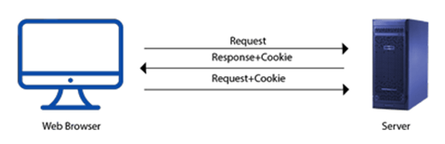A cookie contains the information as a string generally in the form of a name-value pair separated by semi-colons. It maintains the state of a user and remembers the user's information among all the web pages.

**3.3.9.12 How JavaScript Cookies Work?**

* When a user sends a request to the server, then each of that request is treated as a new request sent by the different user.
* So, to recognize the old user, we need to add the cookie with the response from the server at the browser on the client-side.
* Now, whenever a user sends a request to the server, the cookie is added with that request automatically. Due to the cookie, the server recognizes the users.

**3.3.9.13 How to create a Cookie in JavaScript**

In JavaScript, we can create, read, update and delete a cookie by using **document.cookie** property.

**Syntax:**

document.cookie="name=value";

**Example:**

**<html>**

**<head>**

**</head>**

**<body>**

**<input** type="button" value="setCookie" onclick="setCookie()"**>**

**<input** type="button" value="getCookie" onclick="getCookie()"**>**

**<script>**

function setCookie()

     {

         document.cookie="username=Duke Martin";

}

     function getCookie()

     {

         if(document.cookie.length!=0)

         {

         alert(document.cookie);

        }

         else

         {

         alert("Cookie not available");

         }

    }

**</script>**

**</body>**

**</html>**

**3.3.9.14 JavaScript Exception Handling**

An exception signifies the presence of an abnormal condition which requires special operable techniques. In programming terms, an exception is the anomalous code that breaks the normal flow of the code. Such exceptions require specialized programming constructs for its execution.

In programming, exception handling is a process or method used for handling the abnormal statements in the code and executing them. It also enables to handle the flow control of the code/program. For handling the code, various handlers are used that process the exception and execute the code. **For example**, the Division of a non-zero value with zero will result into infinity always, and it is an exception. Thus, with the help of exception handling, it can be executed and handled.

* **In exception handling:**
* A throw statement is used to raise an exception. It means when an abnormal condition occurs, an exception is thrown using throw.
* The thrown exception is handled by wrapping the code into the try…catch block. If an error is present, the catch block will execute, else only the try block statements will get executed.
* Thus, in a programming language, there can be different types of errors which may disturb the proper execution of the program.

**3.3.9.15 Types of Errors**

While coding, there can be three types of errors in the code:

1. **Syntax Error:** When a user makes a mistake in the pre-defined syntax of a programming language, a syntax error may appear.
2. **Runtime Error:** When an error occurs during the execution of the program, such an error is known as Runtime error. The codes which create runtime errors are known as Exceptions. Thus, exception handlers are used for handling runtime errors.
3. **Logical Error:** An error which occurs when there is any logical mistake in the program that may not produce the desired output, and may terminate abnormally. Such an error is known as Logical error.

### **3.3.9.16 Error Object**

### When a runtime error occurs, it creates and throws an Error object. Such an object can be used as a base for the user-defined exceptions too. An error object has two properties:

1. **name:** This is an object property that sets or returns an error name.
2. **message:** This property returns an error message in the string form.

Although Error is a generic constructor, there are following standard built-in error types or error constructors beside it:

1. **Eval Error:** It creates an instance for the error that occurred in the eval(), which is a global function used for evaluating the js string code.
2. **Internal Error:** It creates an instance when the js engine throws an internal error.
3. **RangeError:** It creates an instance for the error that occurs when a numeric variable or parameter is out of its valid range.
4. **Reference Error:** It creates an instance for the error that occurs when an invalid reference is de-referenced.
5. **Syntax Error:** An instance is created for the syntax error that may occur while parsing the eval().
6. **Type Error:** When a variable is not a valid type, an instance is created for such an error.
7. **URI Error:** An instance is created for the error that occurs when invalid parameters are passed in **encodeURI()** or **decodeURI()**.

**3.3.9.17 Exception Handling Statements**

There are following statements that handle if any exception occurs:

* throw statements
* try…catch statements
* try…catch…finally statements.

**3.3.9.17 JavaScript vs PHP**

PHP extends for **Hypertext Preprocessor.** It is the most widely used web development language. It is commonly known as an open-source scripting language. PHP code can be embedded into html files. The code is written between start and end processing instructions, i.e., in-between <?php and ?>. PHP is a simple to use language for a newcomer too.

Although, both [PHP](https://www.javatpoint.com/php-tutorial) and [JavaScript](https://www.javatpoint.com/javascript-tutorial) are used in web development, they serve totally different purposes and tasks. Even in some cases, PHP and JavaScript work together to achieve a common goal. When both languages deal together, JavaScript handles the front-end of the [website](https://www.javatpoint.com/website) and PHP as backend. But, when they work independently, both can serve in the web development majorly. Most popular and trending websites such as Facebook, Yahoo, and Flickr are built using JavaScript as well as PHP together.

## 3.3.9.18 Difference between JavaScript and PHP

Following lists the various differences between JavaScript and PHP.

|  |  |  |
| --- | --- | --- |
| **S. No.** | **JavaScript** | **PHP** |
| **1.** | Currently, it is a full-stack programming language. It means it can serve both the client as well as server sites. | It is a server-side scripting language. It serves only the backend of the website. |
| **2.** | It is faster but difficult to learn. | It is slower but easy to learn. |
| **3.** | It is an asynchronous programming language that does not wait for the execution of the input-output operations. | It is a synchronous programming language. Thus, it waits for the execution of the input-output operations. |
| **4.** | It is supportable by every web browser, such as Mozilla, Google Chrome, and many more. | It is supportable on Windows, Linux, Mac, etc. platforms. Supported by IIS, Apache web servers. |
| **5.** | It carries less securable code. | PHP code is highly securable. |
| **6.** | It requires an environment for accessing the database. | It allows easy and direct access to the database. |
| **7.** | The code is written within <script>...<script> tags. | The code is written within <?php....?> tag. |
| **8.** | Earlier, JavaScript was able to create interactive pages for the clients. But, at present, it is able to build real-time games and applications, mobile applications, too. | A PHP program is able to generate dynamic pages, send cookies, receive cookies, collect form data, etc. |
| **9.** | It is a single-threaded language. Thus, each input-output operation is concurrently carried out. | It is a multi-threaded language. Thus, it blocks if multiple input-output operations execute. |
| **10.** | The extension used to save an external JavaScript file is '.js'. | Files are saved using '.php' extension. |
| **11.** | We can embed the js code in HTML, XML, and AJAX. | We can embed the PHP code only with HTML. |
| **12.** | It supports fewer features. | It supports more advanced features as compared to JavaScript. |
| **13.** | Popular frameworks of JavaScript are Angular, React, Vue.js, Meteor, etc. | Popular frameworks of PHP are Laravel, Symfony, FuelPHP, CakePHP, and many more. |
| **14.** | Websites built in JavaScript are Twitter, LinkedIn, Amazon, etc. | Websites built in PHP are Wordpress, Tumblr, MailChimp, iStockPhoto, etc. |

* + 1. **BOOTSTRAP**

**3.3.10.1 Introduction**

Bootstrap is a powerful, feature-packed frontend toolkit. There are many versions of Bootstrap, but we used Bootstrap 5.2 as it is the newest version of Bootstrap. Bootstrap is the one most popular HTML, CSS, and JavaScript framework for creating responsive, mobile-first websites. There are two ways to add Bootstrap to our website:

1. Using an online CDN
2. Linking Bootstrap file with the source file of our website

**3.3.10.2 Advantages of Bootstrap:**

1. Fewer Cross browser bugs.
2. A consistent framework that supports major of all browsers and CSS compatibility fixes.
3. Lightweight and customizable.
4. Responsive structures and styles.
5. Several JavaScript plugins using the jQuery.
6. Good documentation and community support.
7. Loads of free and professional templates, WordPress themes and plugins.
8. Great grid system.

**3.3.10.3 Disadvantages of Bootstrap:**

1. There will be requirement of lots of style overrides or rewriting files that can thus lead to a lot of time spent on designing and coding the website if the design tends to deviate from the customary design used in Bootstrap.
2. You would have to go the extra mile while creating a design otherwise all the websites will look the same if you don’t do heavy customization.
3. Styles are verbose and can lead to lots of output in HTML which is not needed.
4. JavaScript is tied to jQuery and is one of the commonest library which thus leaves most of the plugins unused.
5. Non-compliant HTML.

**3.3.10.4 Classes**

1. **Breakpoints:** Breakpoints are customizable widths that determine how our responsive layout behaves across devices or viewport sizes in Bootstrap. Bootstrap includes default six breakpoints for building responsively which are mentioned below:

|  |  |  |
| --- | --- | --- |
| Breakpoint | Class infix | Dimensions |
| Extra small | *None* | <576px |
| Small | Sm | ≥576px |
| Medium | Md | ≥768px |
| Large | Lg | ≥ 992px |
| Extra large | Xl | ≥1200px |
| Extra extra large | Xxl | ≥1400px |

|  |  |  |  |  |  |  |
| --- | --- | --- | --- | --- | --- | --- |
|  | Extra small  <576px | Small  ≥576px | Medium  ≥768px | Large  ≥992px | X-Large  ≥1200px | XX-Large  ≥1400px |
| .container | 100% | 540px | 720px | 960px | 1140px | 1320px |
| .container-sm | 100% | 540px | 720px | 960px | 1140px | 1320px |
| .container-md | 100% | 100% | 720px | 960px | 1140px | 1320px |
| .container-lg | 100% | 100% | 100% | 960px | 1140px | 1320px |
| .container-xl | 100% | 100% | 100% | 100% | 1140px | 1320px |
| .container-xxl | 100% | 100% | 100% | 100% | 100% | 1320px |
| .container-fluid | 100% | 100% | 100% | 100% | 100% | 100% |

1. **Containers:** Containers are a fundamental building block of Bootstrap that contain, pad, and align our content within a given device or viewport. The classes of containers available in Bootstrap are as under:
2. **Forms:** Bootstrap provides us with classes that helps us make our HTML looks better and responsive.

Bootstrap provides us with the following types of class which help to improve the visual display of the elements of HTML Form:

1. **Form Control:** Style textual inputs and text-areas with support for multiple states.
2. **Checks & radios:** Use Bootstrap’s custom radio buttons and checkboxes in forms for selecting input options.
3. **Input group:** Attach labels and buttons to your inputs for increased semantic value.
4. **Layout:** Create inline, horizontal, or complex grid-based layouts with our forms.
5. **Select:** Improve browser default select elements with a custom initial appearance.
6. **Range:** Replace browser default range inputs with Bootstrap’s custom version.
7. **Floating Labels:** Create beautifully simple form labels that float over our input fields.
8. **Validation:** Validate our forms with custom or native validation behaviours and styles.
9. **Borders:** We can use Bootstrap’s border utilities to quickly style the border and border-radius of an element. It is great for images, buttons, or any other element. Border utilities that Bootstrap 5.2 provides us are:
10. **Additive:** Add borders to custom elements:
11. border
12. border-top
13. border-end
14. border-bottom
15. bottom-start
16. **Subtractive:** Remove borders of custom elements:
17. border-0
18. border-top-0
19. border-end-0
20. border-bottom-0
21. border-start-0
22. **Color:** Change the border color using utilities based on Bootstrap’s theme colors:
23. border-primary
24. border-secondary
25. border-success
26. border-danger
27. border-warning
28. border-info
29. border-light
30. border-dark
31. border-white

**3.3.11 PHP (HYPERTEXT PREPROCESSOR)**

**3.3.11.1 Introduction**

PHP is a server side scripting language. that is used to develop Static websites or Dynamic websites or Web applications. PHP stands for Hypertext Pre-processor, that earlier stood for Personal Home Pages.PHP is an open-source server-side scripting language that many devs use for web development. It is also a general-purpose language that you can use to make lots of projects, including Graphical User Interfaces (GUIs).

The abbreviation PHP initially stood for Personal Homepage. But now it is a recursive acronym for Hypertext Preprocessor. (It's recursive in the sense that the first word itself is an abbreviation, so the full meaning doesn't follow the abbreviation.) The first version of PHP was launched 26 years ago. Now it's on version 8, released in November 2020, but version 7 remains the most widely used. PHP runs on the Zend engine, which is the most popular implementation. There are some other implementations as well, like parrot, HPVM (Hip Hop Virtual Machine), and Hip Hop, created by Facebook. PHP is mostly used for making web servers. It runs on the browser and is also capable of running in the command line. So, if you don't feel like showing your code output in the browser, you can show it in the terminal.

* + 1. **.2 WHO USE PHP**

A number of established companies and tech giants use PHP to run their servers and make a lot of incredible things.

* Facebook: Facebook uses PHP to power its site. In turn, the company contributed to the community by creating an implementation known as Hip Hop for PHP.
* Wikipedia: one of the world's largest sources of information on any topic, Wikipedia is built in PHP.
* Content Management Systems (CMSs): the world's most popular content management system, WordPress, is built in PHP. Other
* Other content management systems such as Drupal, Joomla, and Magento are also built in PHP. Shopify runs on PHP too.
* Web Hosting Platforms: a lot of Web Hosting Platforms such as BlueHost, Site ground, and Whogohost run their hosting servers using PHP.

**3.3.11.3 IS PHP IS DYING?**

Nowadays, there's an intense debate on whether PHP is on the decline or not. This is because of the advent and increasing popularity of other languages suited for the server-side such as JavaScript (Node JS), Python, Golang, and others. But is PHP really dying? The answer is no. Despite some people bashing on it and the claims of decline, PHP is still used to run the servers of almost 80% of all websites today. So, if you visit 10 websites a day, there's a chance that 8 of them use PHP.

**3.3.11.4 Characteristics of PHP**

* Simple and fast
* Efficient
* Secured
* Flexible
* Cross-platform, it works with major operating systems like Windows, Linux, and macOS.
* Open Source
* Powerful Library Support
* Database Connectivity

**3.3.11.5 Advantages of PHP**

1. The most important advantage of PHP is that it’s open-source and free from cost. It can be downloaded anywhere and is readily available to use for events or web applications.
2. It is platform-independent. PHP-based applications can run on any OS like UNIX, Linux, Windows, etc.
3. Applications can easily be loaded which are based on PHP and connected to the database. It’s mainly used due to its faster rate of loading over slow internet speed than other programming language.
4. It has less learning curve because it is simple and straightforward to use. Someone familiar with C programming can easily work on PHP.
5. It is more stable for a few years with the assistance of providing continuous support to various version
6. It helps in reusing an equivalent code and not got have to write lengthy code and sophisticated structure for events of web applications.
7. It has powerful library support to use various function modules for data representation.
8. It has powerful library support to use various function modules for data representation.
9. PHP’s built-in database connection modules help in connecting databases easily reducing trouble and time for the development of web applications and content-based sites.
10. The popularity of PHP gave rise to various communities of developers, a fraction of which may be potential candidates for hire
11. Flexibility makes PHP ready to effectively combine with many other programming languages in order that the software package could use foremost effective technology for every particular feature.

**3.3.11.6 Disadvantages of PHP**

1. It is not that secure due to its open-source, because the ASCII text file is often easily available
2. It is not suitable for giant content-based web applications.
3. It has a weak type, which can cause incorrect data and knowledge to users.
4. PHP frameworks got to learn to use PHP built-in functionalities to avoid writing additional code.
5. Using more features of PHP framework and tools cause poor performance of online applications.
6. PHP doesn’t allow change or modification in the core behavior of online applications.
7. The PHP frameworks aren’t equivalent in behavior so does their performance and features.
8. While PHP may be a powerful tool supported by an outsized community and plentiful reference documentation, there are easier programming languages for web apps
9. It is widely believed by the developers that PHP features a poor quality of handling errors. PHP lacks debugging tools, which are needed to look for errors and warnings. PHP has less number of debugging tools in comparison to other programming languages.
10. It’s highly tough to manage because it’s not competent modular. It already imitates the features of the Java language.
    * 1. **PHP OPERATORS**

* Arithmetic operators
* Assignment operators
* Increment/Decrement operators
* Logical operators
* String operators
* Array operators
* Conditional assignment operators
  + 1. **PHP CONDITIONAL STATEMENTS**

Very often when you write code, you want to perform different actions for different conditions. You can use conditional statements in your code to do this. In PHP we have the following conditional statements:

* IF statement - executes some code if one condition is true.
* IF-ELSE statement - executes some code if a condition is true and another code if that condition is false.
* If-elseif-else statement - executes different codes for more than two conditions.
* Switch statement - selects one of many blocks of code to be executed.
  + - 1. **IF-Statement:-** The if statement executes some code if one condition is true.

**Syntax:**

if (*condition*)

{

*//code to be executed if condition is true*;  
}

**Example:**

<? php  
$t = date("H");

if ($t < "20")

{  
    echo "Have a good day!";  
}

?>

* + - 1. **IF-ELSE-Statement:-**  The IF-ELSE- statement executes some code if a condition is true and another code if that condition is false.

**Syntax:**

if (*condition*)

{

*code to be executed if condition is true;*  
}

else

{

*//code to be executed if condition is false;*

}

**Example:**

<?php

$t = date("H");

if ($t < "20")

{

echo "Have a good day!";

}

else

{

echo "Have a good night!";

}

?>

* + - 1. **IF-ELSEIF-ELSE:-** The IF-ELSEIF-ELSE statement executes different codes for more than two conditions

**Syntax:**

if (*condition*)

{

*//code to be executed if this condition is true;*

}

elseif (*condition*)

{

//*code to be executed if first condition is false and this condition is true;*

}

else

{

//*code to be executed if all conditions are false;*

}

**Example:**

<?php

$t = date("H");

if ($t < "10")

{

echo "Have a good morning!";

}

elseif ($t < "20")

{

echo "Have a good day!";

}

else

{

echo "Have a good night!";

}

?>

* + - 1. **SWITCH STATEMENT:-** Use theswitchstatement to**select one of many blocks of code to be executed.**

**Syntax:**

switch (n)

{

case label1:

//code to be executed if n=label1;

break;

case label2:

//code to be executed if n=label2;

break;

case label3:

//code to be executed if n=label3;

break;

default:

//code to be executed if n is different from all labels;

}

**Example:**

<?php

$favcolor = "red";

switch ($favcolor) {

case "red":

echo "Your favorite color is red!";

break;

case "blue":

echo "Your favorite color is blue!";

break;

case "green":

echo "Your favorite color is green!";

break;

default:

echo "Your favorite color is neither red, blue, nor green!";

}

?>

* + 1. **PHP LOOPS**

Often when you write code, you want the same block of code to run over and over again a certain number of times. So, instead of adding several almost equal code-lines in a script, we can use loops. Loops are used to execute the same block of code again and again, as long as a certain condition is true.

In PHP, we have the following loop types:

* **WHILE :**- loop through a block of code as long as the specified condition is true
* **DO-WHILE :**- loops through a block of code once, and then repeats the loop as long as the specified condition is true
* **FOR :**- loops through a block of code a specified number of times
* **Foreach :**- loops through a block of code for each element in an array
  + - 1. **While loop** - Loops through a block of code as long as the specified condition is true.

**Syntax:-**

while (*condition is true*)

{

*//code to be executed*;

}

**Example:**

<?php

$x = 1;

while($x <= 5)

{

echo "The number is: $x <br>";

$x++;

}

?>

* + - 1. **Do...while loop:-** The do...while loop - Loops through a block of code once, and then repeats the loop as long as the specified condition is true.

**Syntax:**

Do

{

*//code to be executed;*

}

while (*condition is true*);

**Example:**

<?php

$x = 1;

Do

{

echo "The number is: $x <br>";

$x++;

}

while ($x <= 5);

?>

* + - 1. **FOR-LOOP:-** The for loop is used when you know in advance how many times the script should run.

**Syntax**:

for (*init counter; test counter; increment counter*)

{

//*code to be executed for each iteration;*

}

**Example:**

<?php

for ($x = 0; $x <= 10; $x++)

{

echo "The number is: $x <br>";

}

?>

* + - 1. **FOREACH LOOP :-** The foreach loop works only on arrays, and is used to loop through each key/value pair in an array.

**Syntax:**

foreach ($*array*as$*value*)

{

*//code to be executed;*

}

**Example:**

<?php

$colors = array("red", "green", "blue", "yellow");

foreach ($colors as $value)

{

echo "$value <br>";

}

?>

* + 1. **ARRAY: -** An array is a special variable, which can hold more than one value at a time. If you have a list of items (a list of car names, for example), storing the cars in single variables could look like this:

$cars1 = "Volvo";  
$cars2 = "BMW";  
$cars3 = "Toyota";

An array can hold many values under a single name, and you can access the values by referring to an index number.

* + - 1. **TYPES OF ARRAY**
* Indexed arrays
* Associative arrays
* Multidimensional arrays
  1. **Indexed Array: -** PHP index is represented by number which starts from 0. We can store number, string and object in the PHP array. All PHP array elements are assigned to an index number by default. There are two ways to define indexed array:

**1st way:**

$season=array("summer","winter","spring","autumn");

**2nd way:**

$season[0]="summer";

$season[1]="winter";

$season[2]="spring";

$season[3]="autumn";

**Example:-**

<?php

$season=**array**("summer","winter","spring","autumn");

echo "Season are: $season[0], $season[1], $season[2] and $season[3]";

?>

* 1. **Associative arrays:-** Associative arrays are used to store key value pairs. For example, to store the marks of different subject of a student in an array, a numerically indexed array would not be the best choice. There are two ways to define associative array

**1st way:**

$salary=array("Sonoo"=>"350000","John"=>"450000","Kartik"=>"200000");

**2nd way:**

$salary["Sonoo"]="350000";

$salary["John"]="450000";

$salary["Kartik"]="200000";

**Example:**

<?php

$salary=array("Sonoo"=>"350000","John"=>"450000","Kartik"=>"200000");

echo "Sonoo salary: ".$salary["Sonoo"]."<br/>";

echo "John salary: ".$salary["John"]."<br/>";

echo "Kartik salary: ".$salary["Kartik"]."<br/>";

?>

* 1. **Multidimensional array:-** A multidimensional array is an array containing one or more arrays. PHP supports multidimensional arrays that are two, three, four, five, or more levels deep. However, arrays more than three levels deep are hard to manage for most people.

**Example:**

<?php

echo $cars[0][0].": In stock: ".$cars[0][1].", sold: ".$cars[0][2].".<br>";

echo $cars[1][0].": In stock: ".$cars[1][1].", sold: ".$cars[1][2].".<br>";

echo $cars[2][0].": In stock: ".$cars[2][1].", sold: ".$cars[2][2].".<br>";

echo $cars[3][0].": In stock: ".$cars[3][1].", sold: ".$cars[3][2].".<br>";

?>

* + 1. **PHP GET& POST METHOD**

There are two ways the browser client can send information to the web server.

* The GET Method
* The POST Method

Before the browser sends the information, it encodes it using a scheme called URL encoding. In this scheme, name/value pairs are joined with equal signs and different pairs are separated by the ampersand. Spaces are removed and replaced with the *+* character and any other non-alphanumeric characters are replaced with a hexadecimal values. After the information is encoded it is sent to the server.

1. **THE GET MATHOD**

The GET method sends the encoded user information appended to the page request. The page and the encoded information are separated by the **?** character.

**http://localhost/index.php?name1=value1&name2=value2**

* The GET method produces a long string that appears in your server logs, in the browser's Location: box.
* The GET method is restricted to send upto 1024 characters only.
* Never use GET method if you have password or other sensitive information to be sent to the server.
* GET can't be used to send binary data, like images or word documents, to the server.
* The data sent by GET method can be accessed using QUERY_STRING environment variable.
* The PHP provides $_GET associative array to access all the sent information using GET method.

**Example:**

<?php

if( $_GET["name"] || $_GET["age"] )

{

echo "Welcome ". $_GET['name']. "<br />";

echo "You are ". $_GET['age']. " years old."

exit();

}

?>

<html>

<body>

<form action = "<?php $_PHP_SELF ?>" method = "GET">

Name: <input type = "text" name = "name" />

Age: <input type = "text" name = "age" />

<input type = "submit" />

</form>

</body>

</html>

1. **THE POST MATHOD**

The POST method transfers information via HTTP headers. The information is encoded as described in case of GET method and put into a header called QUERY_STRING.

* The POST method does not have any restriction on data size to be sent.
* The POST method can be used to send ASCII as well as binary data.
* The data sent by POST method goes through HTTP header so security depends on HTTP protocol. By using Secure HTTP you can make sure that your information is secure.
* The PHP provides $_POST associative array to access all the sent information using POST method.

**Example:**

<?php

if( $_POST["name"] || $_POST["age"] ) {

if (preg_match("/[^A-Za-z'-]/",$_POST['name'] )) {

die ("invalid name and name should be alpha");

}

echo "Welcome ". $_POST['name']. "<br />";

echo "You are ". $_POST['age']. " years old.";

exit();

}

?>

<html>

<body>

<form action = "<?php $_PHP_SELF ?>" method = "POST">

Name: <input type = "text" name = "name" />

Age: <input type = "text" name = "age" />

<input type = "submit" />

</form>

</body>

</html>

## The $_REQUEST variable

The PHP $_REQUEST variable contains the contents of both $_GET, $_POST, and $_COOKIE. We will discuss $_COOKIE variable when we will explain about cookies.

The PHP $_REQUEST variable can be used to get the result from form data sent with both the GET and POST methods.

**Example:**

<?php

if( $_REQUEST["name"] || $_REQUEST["age"] ) {

echo "Welcome ". $_REQUEST['name']. "<br />";

echo "You are ". $_REQUEST['age']. " years old.";

exit();

}

?>

<html>

<body>

<form action = "<?php $_PHP_SELF ?>" method = "POST">

Name: <input type = "text" name = "name" />

Age: <input type = "text" name = "age" />

<input type = "submit" />

</form>

</body>

</html>

* 1. **MYSQL**
* MySQL is a database system used on the web
* MySQL is a database system that runs on a server
* MySQL is ideal for both small and large applications
* MySQL is very fast, reliable, and easy to use
* MySQL uses standard SQL
* MySQL compiles on a number of platforms MySQL is free to download and use
* MySQL is developed, distributed, and supported by Oracle Corporation
* MySQL is named after co-founder Monty Widenius's daughter. My

The data in a MySQL database are stored in tables. A table is a collection of related data, and it consists of columns and rows. MySQL is free and open-source software under the terms of the GNU General Public License, and is also available under a variety of proprietary licenses. MySQL was owned and sponsored by the Swedish company MySQL AB. which was bought by Sun Microsystems (now Oracle Corporation). In 2010, when Oracle acquired Sun. Widenius forked the open-source MySQL project to create MariaDB

MySQL has stand-alone clients that allow users to interact directly with a MySQL database using SQL, but more often MySQL is used with other programs to implement applications that need relational database capability. MySQL is a component of the LAMP web application software stack (and others), which is an acronym for Linux, Apache, MySQL, Perl/PHP/Python. MySQL is used by many database-driven web applications, including Drupal, Joomla, phpBB and WordPress. MySQL is also used by many popular websites, including Facebook, Flickr, MediaWiki, Twitter, and YouTube

* + 1. **The SQL Language**

Structured Query Language (SQL) is the language used to manipulate relational databases. SQL is tied very closely with the relational model. In the relational model, data is stored in structures called relations or tables. Each table has one or more attributes or columns that describe the table. In relational databases, the table is the fundamental building block of a database application. Tables are used to store data on Employees. Equipment, Materials, Warehouses, Purchase Orders, Customer Orders, etc. Columns in the Employee table for example, might be Last Name. First Name Salary, Hire Date. Social Security Number, etc.

### SQL statements are issued for the purpose of:

* **Data definition: -** Defining tables and structures in the database (DB).
* **Data manipulation: -** Inserting new data, Updating existing data, Deleting existing data, and Querying the Database (Retrieving existing data from the database).
* **Data Defination Language (DDL**): - It used to create, alter and drop schema objects such as tables and indexes.
* **Data Manipulation Language (DML**): - It used to manipulate the data within those schema objects.

**4.10.2 SQL Statements**

The following is an alphabetical list of SQL statements that can be issued against an My/SQL database. These commands are available to any user of the My/SQL database Emphasized items are most commonly used.

* **ALTER: -** Change an existing table, view or index definition
* **AUDIT: -** Track the changes made to a table
* **COMMENT: -**Add a comment to a table or column in a table
* **COMMIT: -**Make all recent changes permanent
* **CREATE: -**Create new database objects such as tables or views
* **DELETE: -**Delete rows from a database table
* **DROP: -**Drop a database object such as a table, view or index
* **GRANT: -**Allow another user to access database objects such as tables or views
* **INSERT: -** Insert new data into a database table
* **ROLLBACK: -**Undo any recent changes to the database
* **SELECT: -** Retrieve data from a database table
* **UPDATE:-** Change the values of some data items in a database table
* **CREATE TABLE:-** Create a new table in the database. The table name must not already exist CREATE TABLE has the following syntax:

CREATE TABLE*<table name> (<column1_name> <datatype> <[not]null>,*

*<column2_name> <datatype> <[not]null>,*

*…….*

*);*

### **Creating, Altering and Dropping Tables**

A table is made up of one or more columns (also called attributes in relational theory). Each column is given a name and a data type that reflects the kind of data it will store Oracle supports four basic data types called CHAR. NUMBER. DATE and RAW There are also a few additional variations on the RAW and CHAR data types.

* + 1. **The various data type use in MY/SQL are as under:-**
       1. **String Datatype**
* **CHAR: -** A FIXED length string (can contain letters, numbers, and special characters). The size parameter specifies the column length in characters - can be from 0 to 255. Default is 1
* **VARCHAR**: - A VARIABLE length string (can contain letters, numbers, and special characters). The size parameter specifies the maximum column length in characters - can be from 0 to 65535
* **BINARY: -** Equal to CHAR(), but stores binary byte strings. The size parameter specifies the column length in bytes. Default is 1
* **VARBINARY: -** Equal to VARCHAR(), but stores binary byte strings. The size parameter specifies the maximum column length in bytes.
* **TINYBLOB: -** For BLOBs (Binary Large OBjects). Max length: 255 bytes
* **TINYTEXT: -** Holds a string with a maximum length of 255 characters
* **TEXT(size): -** Holds a string with a maximum length of 65,535 bytes
* **BLOB(size): -** For BLOBs (Binary Large OBjects). Holds up to 65,535 bytes of data
* **MEDIUMTEXT: -** Holds a string with a maximum length of 16,777,215 characters
* **MEDIUMBLOB: -** For BLOBs (Binary Large OBjects). Holds up to 16,777,215 bytes of data
* **LONGTEXT: -** Holds a string with a maximum length of 4,294,967,295 characters
* **LONGBLOB: -** For BLOBs (Binary Large OBjects). Holds up to 4,294,967,295 bytes of data
  + - 1. **Numeric datatype**
* **BIT: -** A bit-value type. The number of bits per value is specified in size. The size parameter can hold a value from 1 to 64. The default value for size is 1.
* **TINYINT: -** A very small integer. Signed range is from -128 to 127. Unsigned range is from 0 to 255. The size parameter specifies the maximum display width (which is 255)
* **SMALLINT: -** A small integer. Signed range is from -32768 to 32767. Unsigned range is from 0 to 65535. The size parameter specifies the maximum display width (which is 255)
* **MEDIUMINT: -** A medium integer. Signed range is from -8388608 to 8388607. Unsigned range is from 0 to 16777215. The size parameter specifies the maximum display width (which is 255)
* **INT: -** A medium integer. Signed range is from -2147483648 to 2147483647. Unsigned range is from 0 to 4294967295. The size parameter specifies the maximum display width (which is 255)
* **INTEGER: -** Equal to INT(size)
* **BIGINT: -** A large integer. Signed range is from -9223372036854775808 to 9223372036854775807. Unsigned range is from 0 to 18446744073709551615. The size parameter specifies the maximum display width (which is 255)
* **FLOAT: -** A floating point number. The total number of digits is specified in size. The number of digits after the decimal point is specified in the d parameter. This syntax is deprecated in MySQL 8.0.17, and it will be removed in future MySQL versions
* **FLOAT: -** A floating point number. MySQL uses the p value to determine whether to use FLOAT or DOUBLE for the resulting data type. If p is from 0 to 24, the data type becomes FLOAT(). If p is from 25 to 53, the data type becomes DOUBLE()
* **DOUBLE: -** A normal-size floating point number. The total number of digits is specified in size. The number of digits after the decimal point is specified in the d parameter.

DOUBLE PRECISION(size, d)

* **DECIMAL: -** An exact fixed-point number. The total number of digits is specified in size. The number of digits after the decimal point is specified in the d parameter. The maximum number for size is 65. The maximum number for d is 30. The default value for size is 10. The default value for d is 0.
* **DEC: -** Equal to DECIMAL(size,d)
  + - 1. **Date and Time Data Type**
* **DATE:-**A date. Format: YYYY-MM-DD. The supported range is from '1000-01-01' to '9999-12-31'
* **DATETIME(fsp): -** A date and time combination. Format: YYYY-MM-DD hh:mm:ss. The supported range is from '1000-01-01 00:00:00' to '9999-12-31 23:59:59'. Adding DEFAULT and ON UPDATE in the column definition to get automatic initialization and updating to the current date and time
* **TIMESTAMP(fsp): -** A timestamp. TIMESTAMP values are stored as the number of seconds since the Unix epoch ('1970-01-01 00:00:00' UTC). Format: YYYY-MM-DD hh:mm:ss. The supported range is from '1970-01-01 00:00:01' UTC to '2038-01-09 03:14:07' UTC. Automatic initialization and updating to the current date and time can be specified using DEFAULT CURRENT_TIMESTAMP and ON UPDATE CURRENT_TIMESTAMP in the column definition
* **TIME(fsp): -** A time. Format: hh:mm:ss. The supported range is from '-838:59:59' to '838:59:59'
* **YEAR: -** A year in four-digit format. Values allowed in four-digit format: 1901 to 2155, and 0000.

MySQL 8.0 does not support year in two-digit format

**CH - 5**

**DESIGN PHASE**

* 1. **DFD of Our Library Management System**

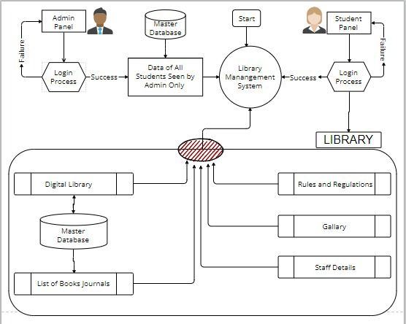

* 1. **Wire-framing of Our Library Management System**

Before we started the project, we decided to make a basic wireframe of the website which helped us a lot during the development as it allowed us to create the basic structure of the website. It also allowed our teachers to interpretate how our final project will look like. Image given below is the part of the wireframe structure we created:

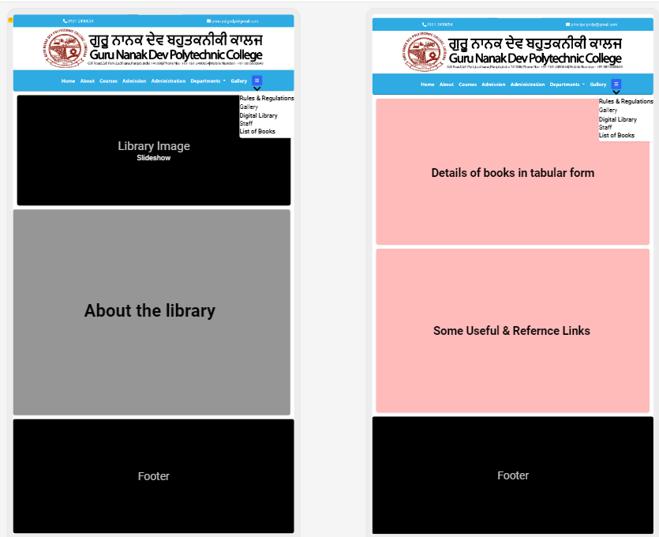

**CH - 6**

**DATABASE DESIGN**

* Database name: - “gndpolyo_web”

|  |  |  |
| --- | --- | --- |
| **Field Name** | **Data type** | **Size** |
| id | INT | 11 |
| user_email | VARCHAR | 255 |
| auth_type | VARCHAR | 255 |
| Selector | TEXT | - |
| Token | LONGTEXT | - |
| created_at | TIMESTAMP | - |
| expires_at | TIMESTAMP | - |

1. Table name: - “admin_auth_tokens”

|  |  |  |
| --- | --- | --- |
| **Field name** | **Data type** | **Size** |
| Accession_No | VARCHAR | 25 |
| Date | DATE | - |
| Bill_No | VARCHAR | 16 |
| Price | BIGINT | 20 |
| Book_Name | VARCHAR | 150 |
| Author_Name | VARCHAR | 150 |
| Publisher_Name | VARCHAR | 150 |
| Place | VARCHAR | 100 |
| Edition | VARCHAR | 10 |
| Year | INT | 4 |
| Volume | BIGINT | 30 |
| Pages | BIGINT | 100 |

1. Table name: - “admin_books”
2. Table name: - “admin_users”

|  |  |  |
| --- | --- | --- |
| **Field Name** | **Data type** | **Size** |
| id | INT | 11 |
| username | VARCHAR | 255 |
| email | VARCHAR | 255 |
| Password | VARCHAR | 255 |
| first_name | VARCHAR | 255 |
| last_name | VARCHAR | 255 |
| gender | CHAR | 1 |
| headline | VARCHAR | 255 |
| Bio | TEXT | - |
| profile_image | VARCHAR | 255 |
| verified_at | TIMESTAMP | - |
| created_at | TIMESTAMP | - |
| updated_at | TIMESTAMP | - |
| deleted_at | TIMESTAMP | - |
| last_login_at | TIMESTAMP | - |

1. Table name: - “auth_tokens”

|  |  |  |
| --- | --- | --- |
| **Field Name** | **Data type** | **Size** |
| Id | INT | 11 |
| user_email | VARCHAR | 255 |
| auth_type | VARCHAR | 255 |
| Selector | TEXT | - |
| Token | LONGTEXT | - |
| created_at | TIMESTAMP | - |
| expires_at | TIMESTAMP | - |

1. Table name: - “branch_wise_book”

|  |  |  |
| --- | --- | --- |
| **Field Name** | **Data type** | **Size** |
| Sr.No | BIGINT | 50 |
| Branch | VARCHAR | 150 |
| Total_Books | BIGINT | 50 |
| Titles | BIGINT | 50 |

1. Table name: - “detail_of_journals”

|  |  |  |
| --- | --- | --- |
| **Field Name** | **Data type** | **Size** |
| Sr.No | INT | 50 |
| Detail_of_journals | VARCHAR | 150 |

1. Table name: - “detail_of_newspaper”

|  |  |  |
| --- | --- | --- |
| **Field Name** | **Data type** | **Size** |
| Sr.No | INT | 50 |
| Detail_of_Newspaper | VARCHAR | 150 |
| Language | VARCHAR | 50 |

1. Table name: - “detail_of_non_tech_magazines”

|  |  |  |
| --- | --- | --- |
| **Field Name** | **Data type** | **Size** |
| Sr.No | INT | 50 |
| Non_Tech_Magazines | VARCHAR | 150 |

1. Table Name: - “detail_of_tech_magazines”

|  |  |  |
| --- | --- | --- |
| **Field Name** | **Data type** | **Size** |
| Sr.No | INT | 50 |
| Tech_Magazines | VARCHAR | 150 |

1. Table Name: - “footerlinks”

|  |  |  |
| --- | --- | --- |
| **Field Name** | **Data type** | **Size** |
| sno | INT | 255 |
| linkname | VARCHAR | 1000 |
| link | VARCHAR | 1000 |

1. Table Name: - “issue_book”
2. Table name: - “library_membership_form”

|  |  |  |
| --- | --- | --- |
| **Field Name** | **Data type** | **Size** |
| mem_no | INT | 11 |
| Date | DATE | - |
| S_Name | VARCHAR | 100 |
| F_ Name | VARCHAR | 100 |
| Mobile_Number | BIGINT | 30 |
| Department | VARCHAR | 50 |
| Semester | INT | 50 |
| Academic_Year | INT | 50 |
| Roll_Number | INT | 50 |
| Registration_Number | INT | 50 |
| email | VARCHAR | 150 |
| Category | VARCHAR | 50 |
| Full_Address | VARCHAR | 300 |
| Student_Profile | VARCHAR | 300 |
| Student_Id | BIGINT | 10 |

1. Table Name: - “lib_news”

|  |  |  |
| --- | --- | --- |
| **Field Name** | **Data type** | **Size** |
| sr_no | BIGINT | 10 |
| title | VARCHAR | 100 |
| description | LONGTEXT | - |
| date | DATE | - |

1. Table Name: - “return_book”

|  |  |  |
| --- | --- | --- |
| **Field Name** | **Data type** | **Size** |
| SR_NO | INT | 50 |
| Non_Tech_Magazines | VARCHAR | 150 |

1. Table Name: - “total_book”

|  |  |  |
| --- | --- | --- |
| **Field Name** | **Data type** | **Size** |
| SR_NO | INT | 50 |
| Total_No_of_Books | VARCHAR | 150 |
| Counting | INT | 50 |

**CH - 7**

**IMPLEMENTATION**

In implementation section, we will see how we will implement the changes which we made to our website with the College Website. Here are the changes we made to the website:

* **Library Home:** We have completely redesigned the Library Home Page giving it a refreshing and modern look. We added the following blocks in the Library Home Page:

1. About the library
2. Our Staff
3. Useful Links – Student Corner & Extra Resources
4. News Section
5. Book Details

* **Rules and Regulations:** It has all the rules and regulations of the Library we need to keep in mind while visiting it in person.
* **Student Dashboard:** Student Dashboard is a place for students, where the students can Signup/Login and then use the following features:

1. Apply for Library Membership Card (if they don’t have already) by filling the Membership Form through the Web Portal. Once the form is filled, it can’t be edited or refilled.
2. Check their issued books and their due dates.
3. Check their fine on the books (if any).
4. Search all the books that are available in the Library.

* **Admin Panel:** Admin Panel is the place for the staff of the library. The staff will be able to use the following features:

1. See the information of students who has applied for the Membership Card
2. Can View, Add or Edit Books
3. Can Issue New Book & Return Book
4. Fine Management
5. View Issued and Returned Books
6. Search Books by each individual department or from all the departments.
7. News Section – Add, View, Edit or Delete the News on the Library Home Page

**CH - 8**

**TESTING**

* + - 1. **Library Home Page**

|  |  |  |  |
| --- | --- | --- | --- |
| **Sr. No.** | **Test Case** | **Expected Result** | **Test Result** |
| **1.** | Open the home page | Webpage should open and fetch the data without any error | Successful |

|  |  |  |  |
| --- | --- | --- | --- |
| **Sr. No.** | **Test Case** | **Expected Result** | **Test Result** |
| **1.** | Enter Name, email, contact no., username & password and then click on Signup. | Webpage should redirect to the Login Page | Successful |
| **2.** | If email or username is already in use | Webpage should not register and display an error. | Successful |

* + - 1. **Student Web Portal Signup page**
      2. **Student Web Portal Login Page**

|  |  |  |  |
| --- | --- | --- | --- |
| **Sr. No.** | **Test Case** | **Expected Result** | **Test Result** |
| **1.** | Enter valid user name & click on login button | Webpage should display the main window | Successful |
| **2.** | Enter invalid details | Webpage should display an error and not login | Successful |

|  |  |  |  |
| --- | --- | --- | --- |
| **Sr. No.** | **Test Case** | **Expected Result** | **Test Result** |
| **1.** | Apply library membership form | Only valid Student apply for this form | Successful |
| **2.** | Admin level | Admin can see the detail of student apply for library form | Successful |

* + - 1. **Library Membership Form**

|  |  |  |  |
| --- | --- | --- | --- |
| **Sr. No.** | **Test Case** | **Expected Result** | **Test Result** |
| **1.** | Enter valid user name & click on login button | Webpage should display the main window | Successful |
| **2.** | Enter invalid details | Webpage should display an error and not login | Successful |

* + - 1. **Admin Web Portal Login Page**

|  |  |  |  |
| --- | --- | --- | --- |
| **Sr. No.** | **Test Case** | **Expected Result** | **Test Result** |
| **1.** | Test all linked URLs | All URLs working and linked to valid webpages | Successful |
| **2.** | News Section | Add, View or Delete News | Successful |

* + - 1. **Admin Web Portal Dashboard**
      2. **Admin Manage Library Page**

|  |  |  |  |
| --- | --- | --- | --- |
| **Sr. No.** | **Test Case** | **Expected Result** | **Test Result** |
| **1.** | Test all linked URLs | All URLs working and linked to valid webpages | Successful |
| **2.** | Manage Books Block | All Buttons linked properly and perform a specific task | Successful |
| **3.** | Fine Management Block | All Buttons linked properly and perform a specific task | Successful |
| **4.** | Department Wise Books Block | All Buttons linked properly and perform a specific task | Successful |

* + - 1. **Digital Library**

|  |  |  |  |
| --- | --- | --- | --- |
| **Sr. No.** | **Test Case** | **Expected Result** | **Test Result** |
| **1.** | Test all linked URLs | All URLs working and linked to valid webpages | Successful |
| **2.** | Header links | All URLs working and linked to valid webpages | Successful |
| **3.** | Department Wise Books Block | All Buttons linked properly and perform a specific task | Successful |
| **4.** | Footer Links | All important links linked to |  |

**CH - 9**

**MAINTENANCE**

Website Maintenance is the act of regularly checking your website for issues and mistakes and keeping it updated and relevant. This should be done on a consistent basis in order to keep your website healthy, encourage continued traffic growth, deliver a positive user experience, and strengthen your [SEO and Google rankings](https://fingerprintmarketing.com/getting-your-content-to-rank-on-page-one-of-google-search/). Given below are some common ways to maintain our website:

* Regularly check that all the web pages are loading without errors.
* Review SEO and Meta titles and descriptions to ensure they are as effective as possible.
* Redundant and false information must be removed from the database regularly.
* Use phpMyAdmin to manipulate the database.
* Newer version of PHP and MYSQL should be used for upgradation of Website and to improve the overall performance of the website
* Keep the website updated up to the latest trends
* Keep the backup of the complete website files
* Analyse security scans and if there are any issues, make sure they're resolved
* Analyse website statistics

**CH – 10**

**CONCLUSION**

Theoretical knowledge without proper practical knowledge is waste. Making a project doesn't just help in clearing the concepts but also eradicates the problem in implementation. This project also helps us to understand the PHP and many technologies with different pre-defined functions of PHP and many functions of JavaScript and jQuery.

With the help of various links and tools, we have been able to provide a site which is running on web. We have successfully created a Library Management website. We have tested it and solved all the bugs which were in the website. We designed the website in such a way so anyone who uses it for the first time will find it quite user friendly interface. Now it is running properly without any lag or bug.

**CH – 11**

**FUTURE SCOPE**

To implement the project at large stage by adding our website on our college **Guru Nanak Dev Polytechnic College** website at www.gndpoly.org. For this procedure, we have to add more feature in our website like upload pdf of all semester books according to subject and department, Library Membership Card Apply Form, Issue Book Form and we have to get permission from college to do this. We've uploaded all the code of the website including API, images, coding and everything on "GitHub", it is uploaded in a private repository which can be accessed by us and it can act as a backup for the college in case something happens to the website.

**By clicking the link below you can access the code on GitHub:**

<https://github.com/brahamjot-gndpc/GNDPC-Library.git>

**CH – 12**

**ANNEXURE**

* **Library Home Page**

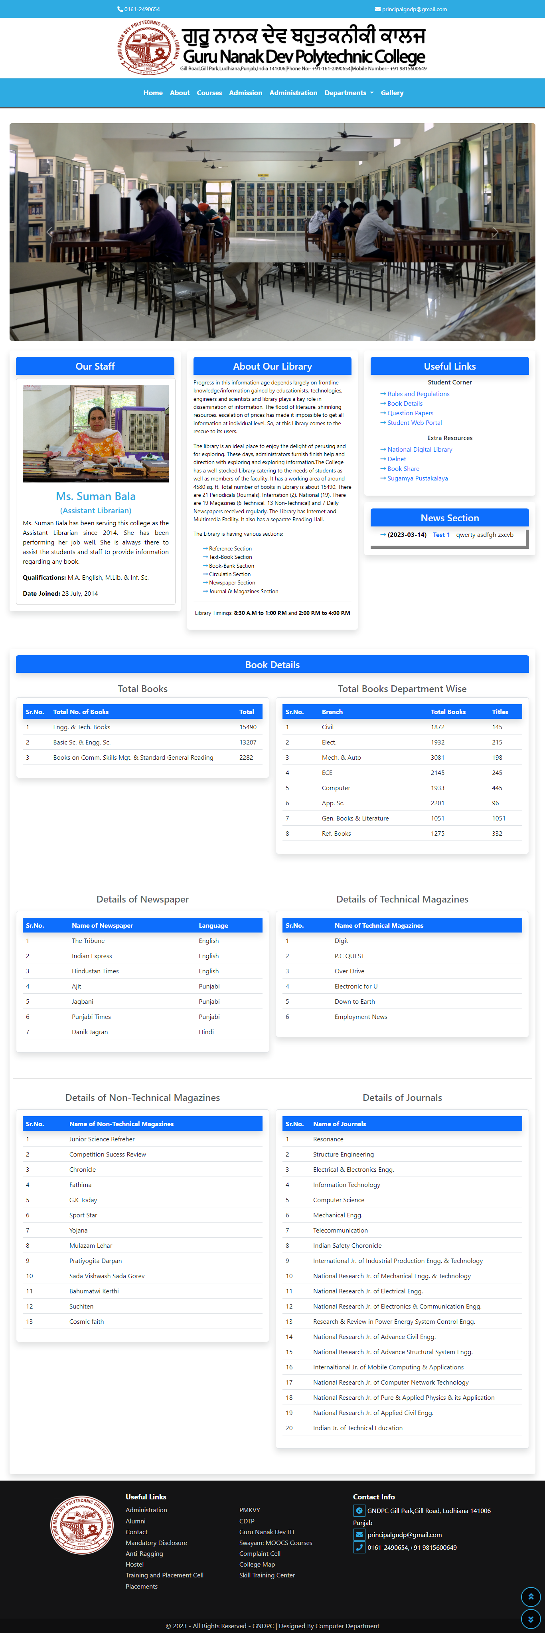

* **Rules And Regulations**

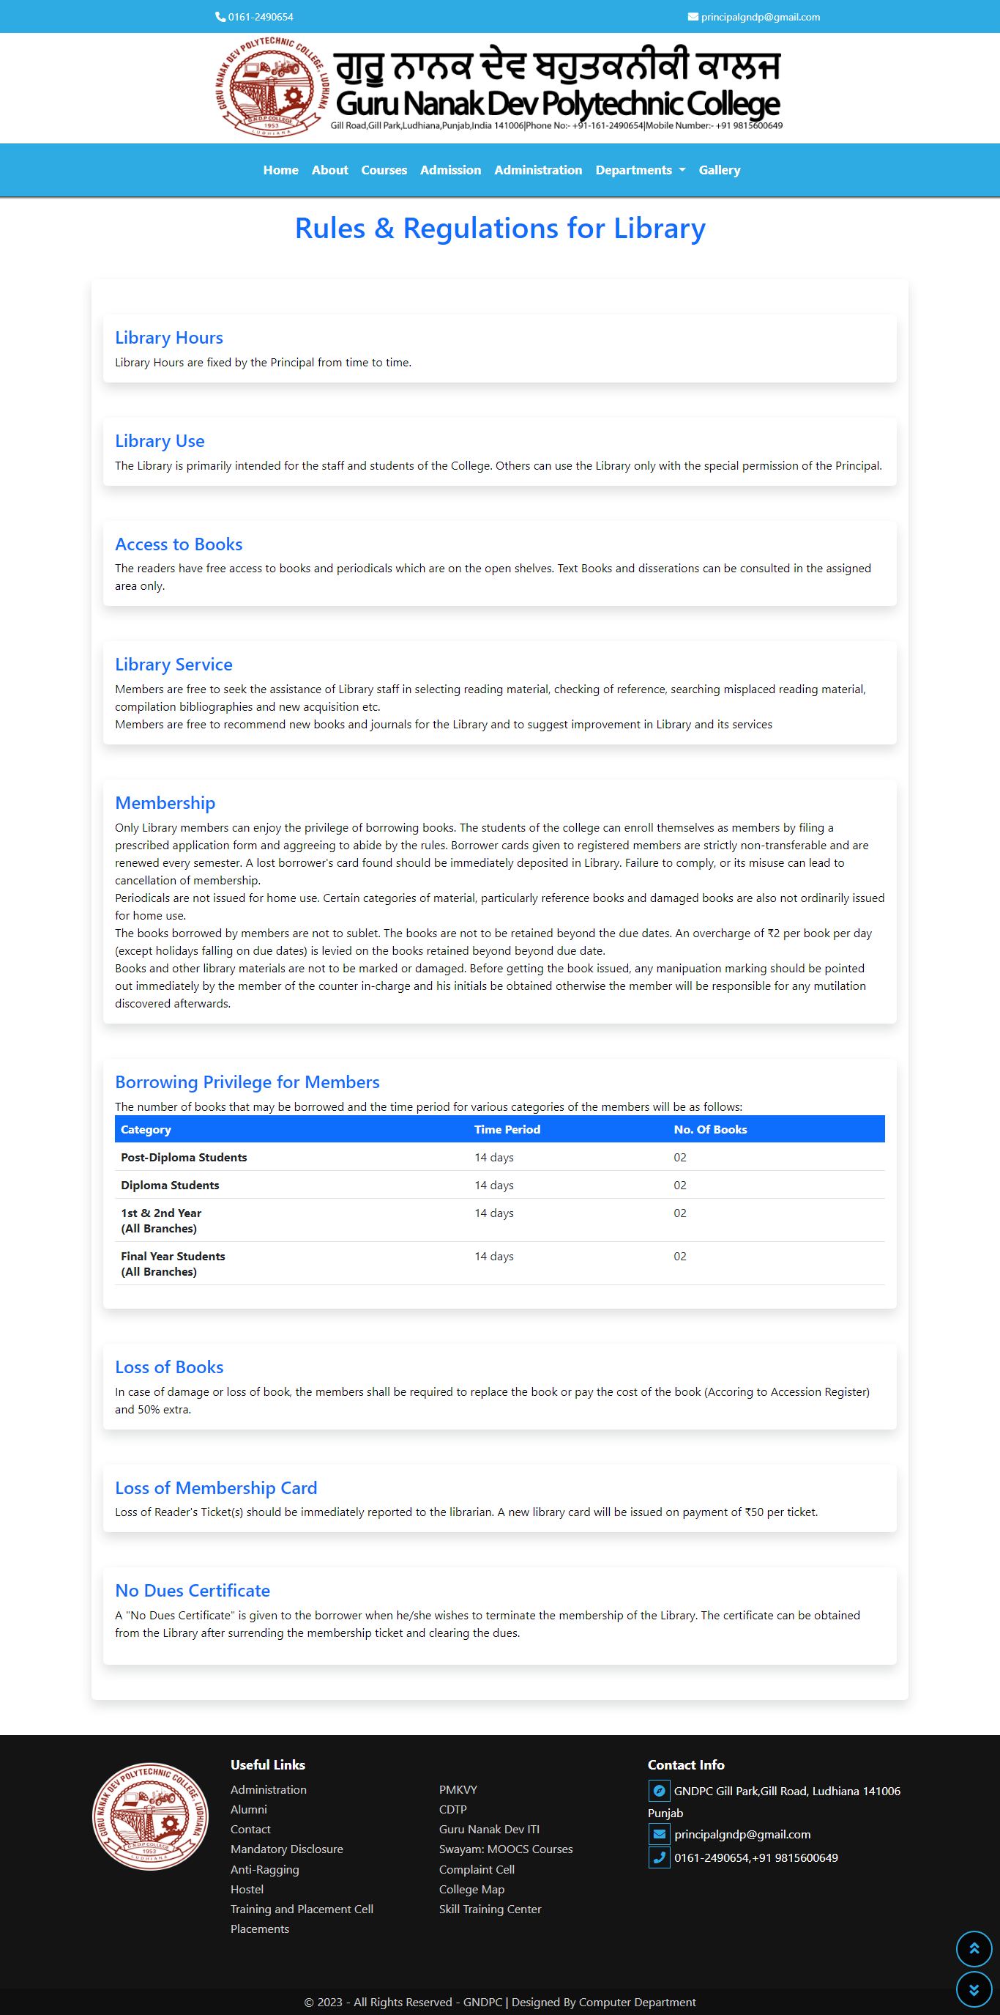

* **Admin Panel Login Page**

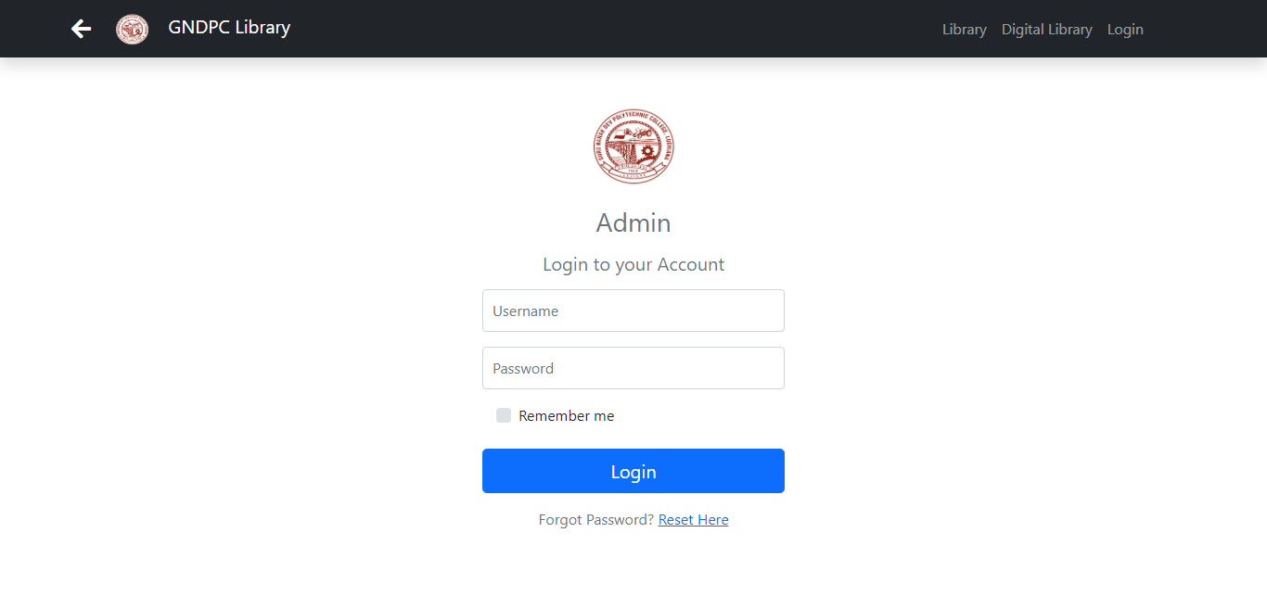

* **Admin Panel Dashboard**

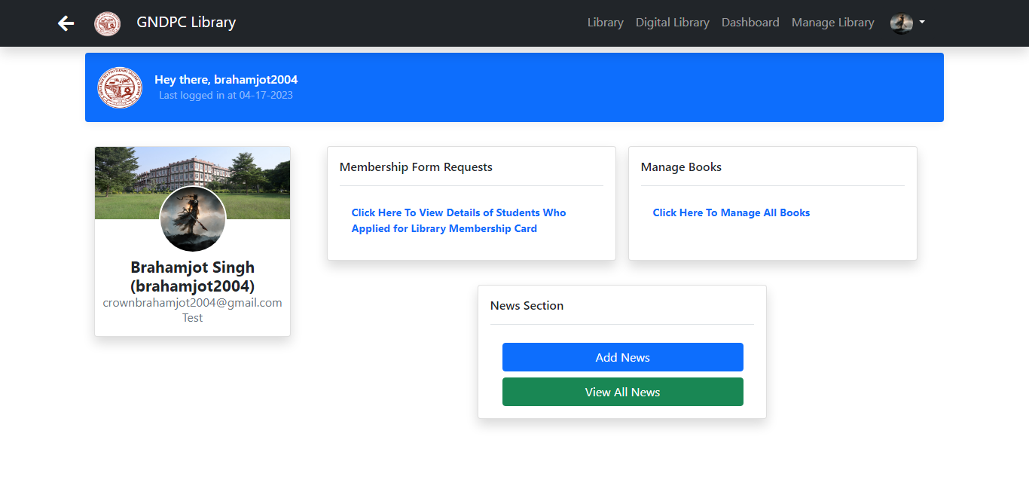

* **Admin Manage Library Page**



* **Student Web Portal Login**

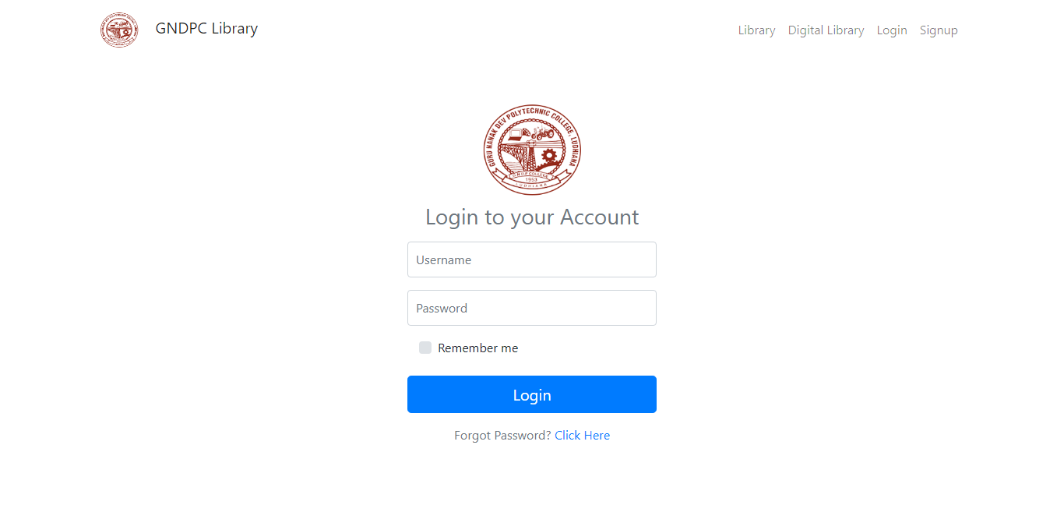

* **Student Web Portal Dashboard**

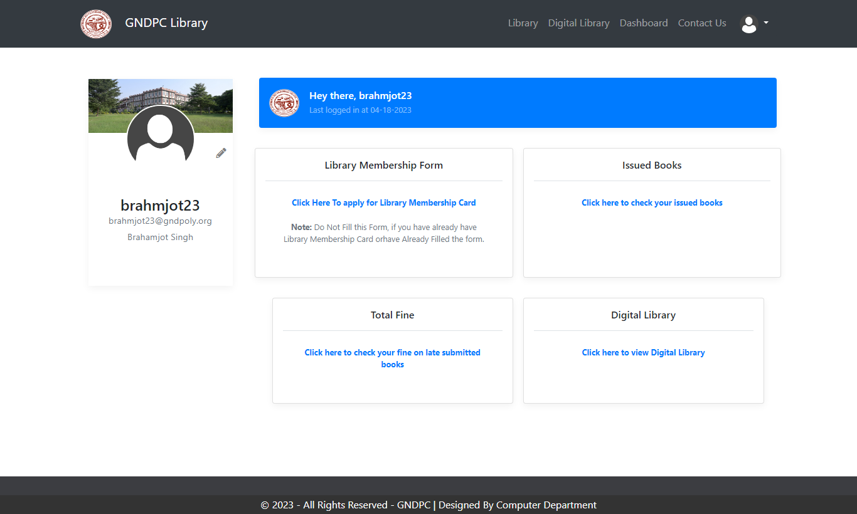

* **Library Membership Form**

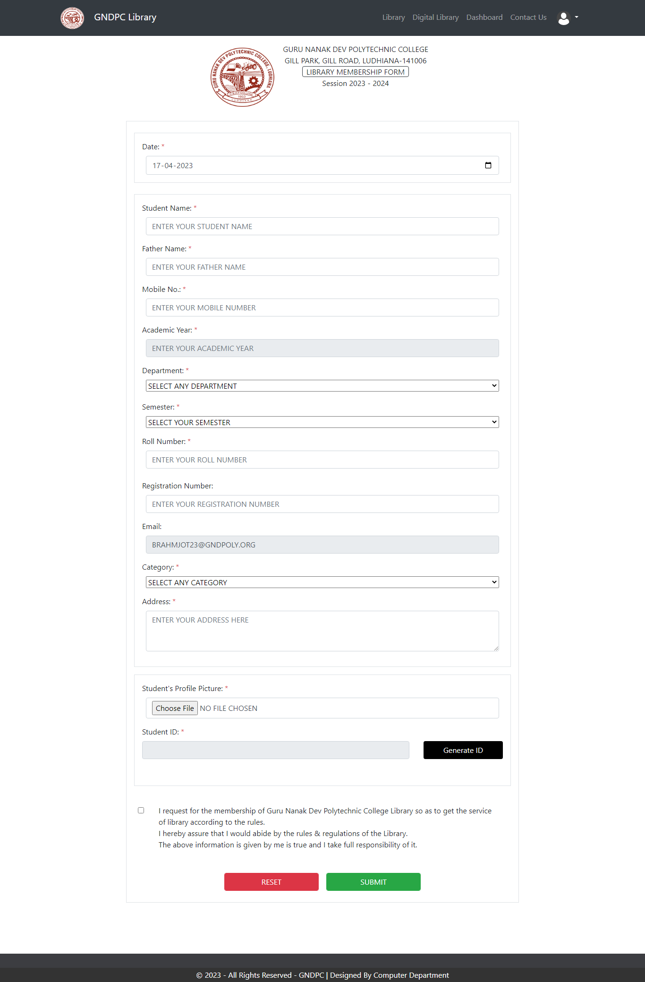

* **Digital Library**

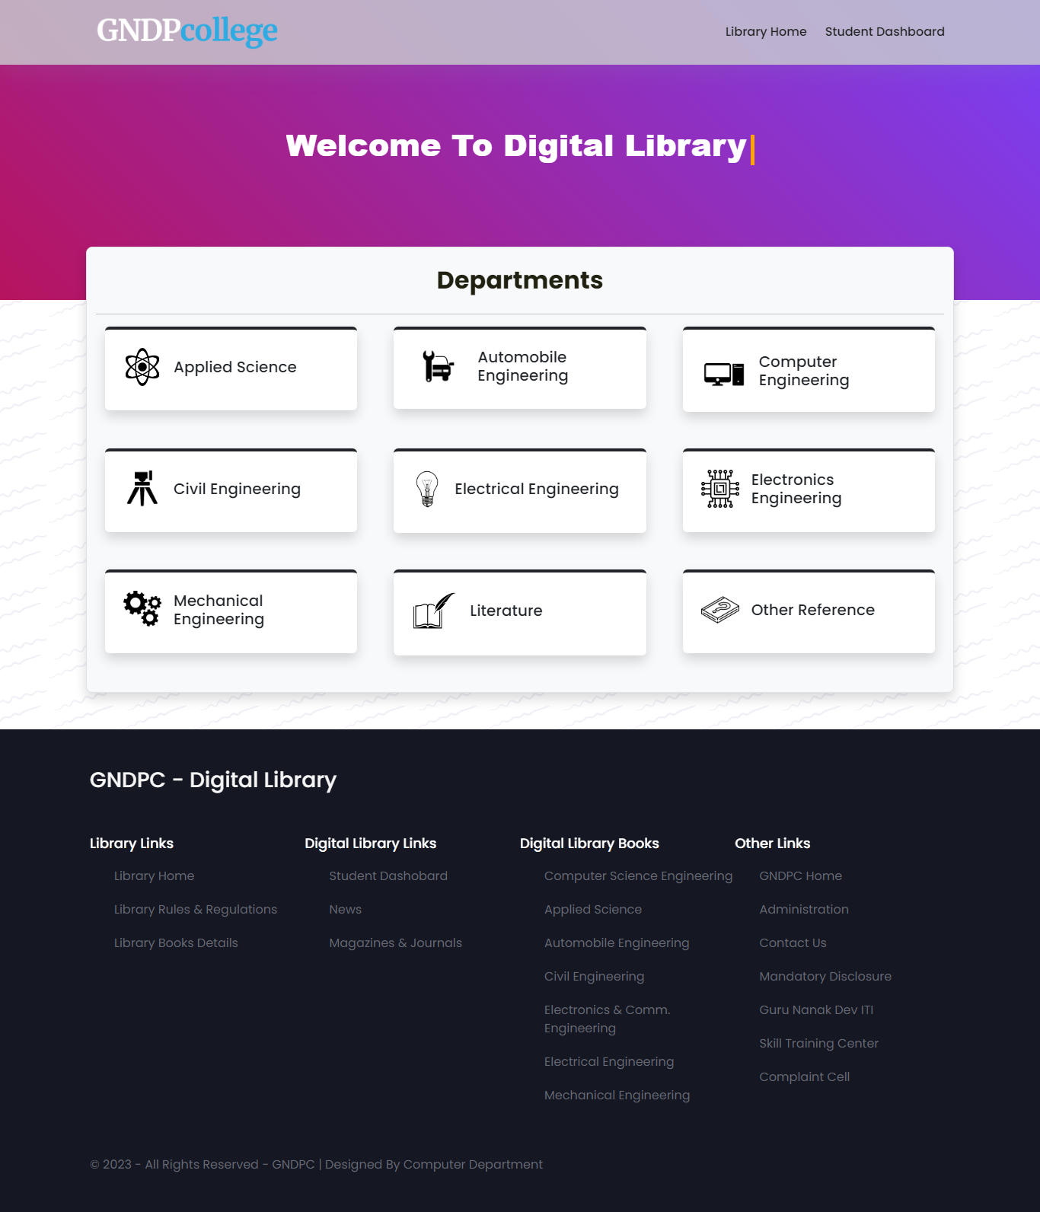

**CH - 13**

**BIBLIOGRAPHY**

<https://www.geeksforgeeks.org> 🡪 Php Code Reference

<https://www.tutorialspoint.com> 🡪 JavaScript Code References

<https://www.javatpoint.com> 🡪 JavaScript Code References

<https://www.stackoverflow.com> 🡪 Coding Error related problem solving from here

<https://www.youtube.com> 🡪 Design Reference from YouTube

<https://github.com/> 🡪 Coding reference for the Login, Signup & Contact Page Design